Task 1: Create a VPC in the N. Virginia Region

Objective
Create a Virtual Private Cloud (VPC) in the N. Virginia (us-east-1) region to provide an isolated network environment where all AWS resources (subnets, EC2 instances, load balancer, NAT Gateway, etc.) will be deployed.

Prerequisites
Before creating the VPC, ensure the following:
- An active AWS account.
- IAM user or role with permissions to manage VPC resources.
- AWS Management Console access.
- Region selected as N. Virginia (us-east-1).

Steps
- Sign in to the AWS Management Console.
- From the Region selector, choose N. Virginia (us-east-1).
- Navigate to VPC Dashboard.
- Click Create VPC.
- Select VPC only.
- Enter the following details:
Setting | Value
Name tag | Demo-VPC
IPv4 CIDR Block | 10.0.0.0/16
IPv6 CIDR Block | None
Tenancy | Default
- Click Create VPC.
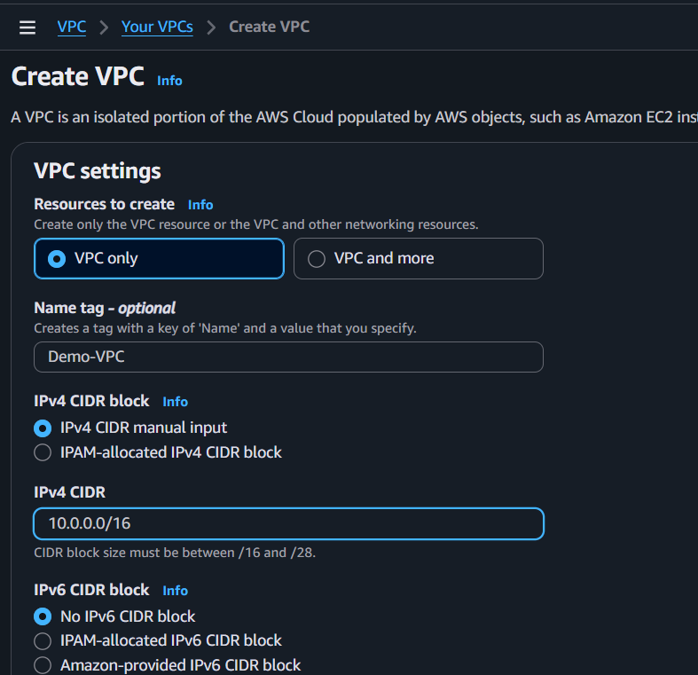

Verification
After the VPC is created:
- The VPC status should display Available.
- The IPv4 CIDR block should be 10.0.0.0/16.
- The VPC should appear in the VPC dashboard under Your VPCs.

Expected Outcome

A new VPC named Demo-VPC is successfully created in the N. Virginia (us-east-1) region with the CIDR block 10.0.0.0/16. This VPC serves as the foundation for all subsequent networking and compute resources in the project.
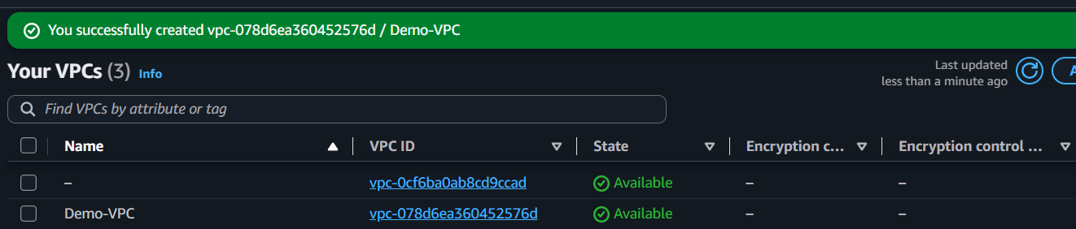
Task 2: Create Two Subnets (One Public and One Private)

Objective
Create one public subnet and one private subnet within the existing VPC to separate internet-facing resources from internal resources.

Prerequisites
- AWS account with access to the N. Virginia (us-east-1) region.
- Demo-VPC created with CIDR block 10.0.0.0/16 (Task 1 completed).

Implementation Steps
- Sign in to the AWS Management Console.
- Select the N. Virginia (us-east-1) region.
- Navigate to VPC → Subnets.
- Click Create subnet.
- Select Demo-VPC.
- Create the Public Subnet with the following configuration:
  - Subnet Name: Public-Subnet
  - Availability Zone: us-east-1a (or any available AZ)
  - IPv4 CIDR Block: 10.0.1.0/24
- Click Add new subnet.
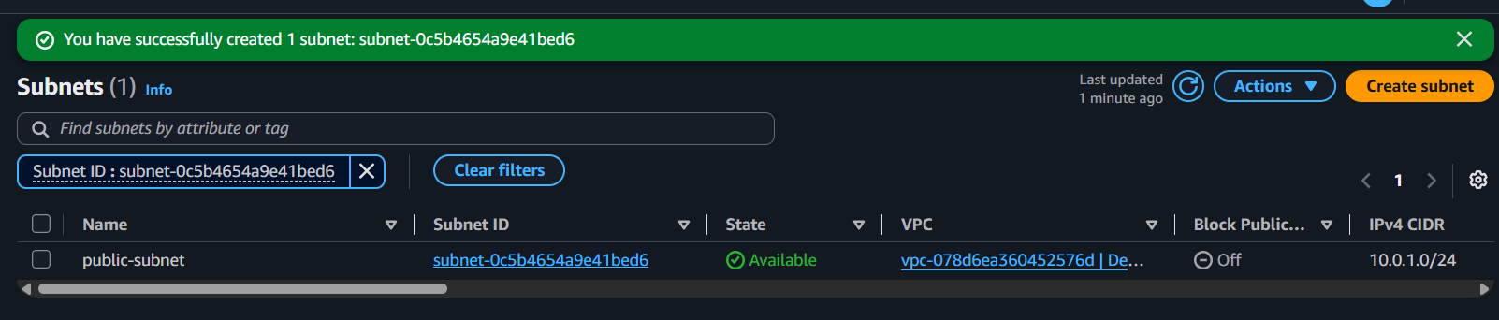
- Create the Private Subnet with the following configuration:
  - Subnet Name: Private-Subnet
  - Availability Zone: Same AZ as the public subnet
  - IPv4 CIDR Block: 10.0.2.0/24
- Click Create subnet.
- Verify that both subnets are in the Available state.
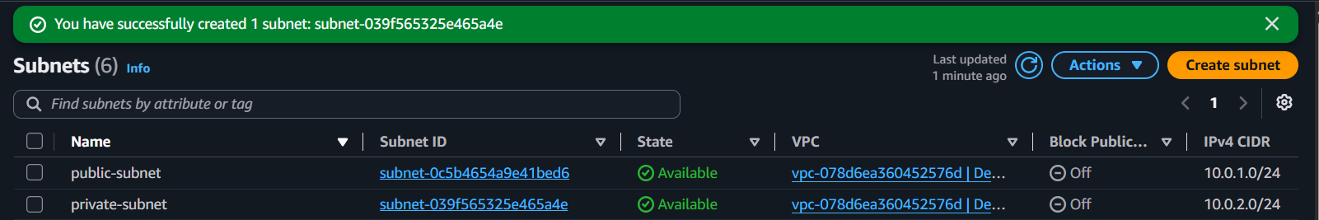

Expected Outcome
- Demo-VPC contains two subnets:
  - Public-Subnet (10.0.1.0/24)
  - Private-Subnet (10.0.2.0/24)
- Both subnets are successfully created and displayed under VPC → Subnets.
- Create one more subnet for ALB task
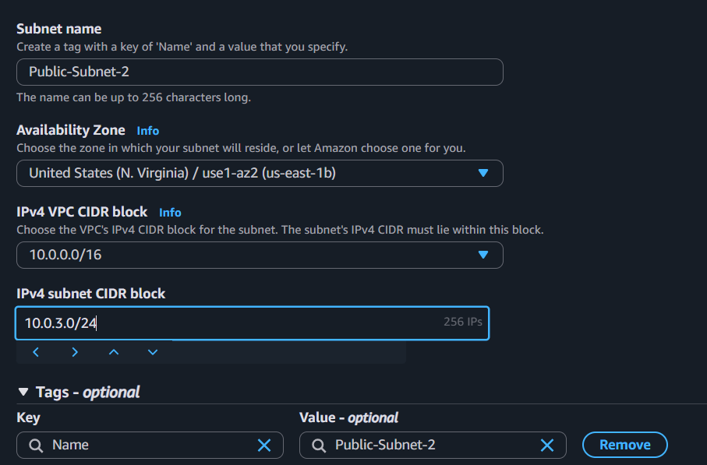
- Add subnet association in route table
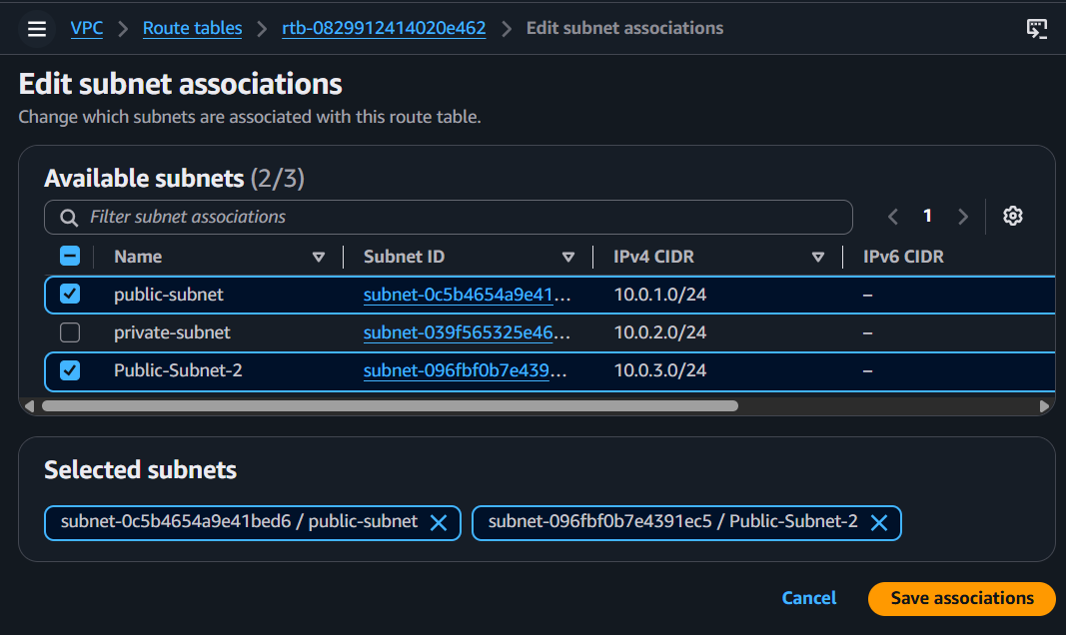

Task 3: Attach an Internet Gateway (IGW) to the VPC

Objective
Create an Internet Gateway (IGW) and attach it to the Project-VPC to enable internet connectivity for resources in the public subnet.

Prerequisites
- AWS account with access to the N. Virginia (us-east-1) region.
- Demo-VPC created (Task 1 completed).
- Public-Subnet and Private-Subnet created (Task 2 completed).

Implementation Steps
- Sign in to the AWS Management Console.
- Select the N. Virginia (us-east-1) region.
- Navigate to VPC → Internet Gateways.
- Click Create internet gateway.
- Enter the following details:
  - Name: Project-IGW
- Click Create internet gateway.
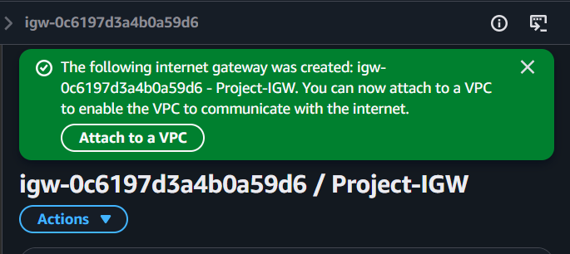
- Select the newly created Project-IGW.
- Click Actions → Attach to VPC.
- Select Demo-VPC.
- Click Attach internet gateway.
- Verify that the Internet Gateway is attached to Project-VPC.
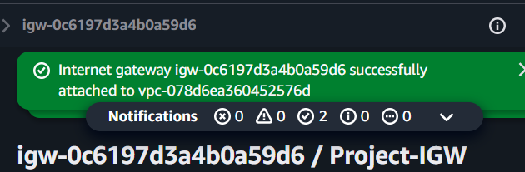

Expected Outcome
- An Internet Gateway named Project-IGW is created.
- Project-IGW is successfully attached to Demo-VPC.
- The Internet Gateway status shows Attached under VPC → Internet Gateways.
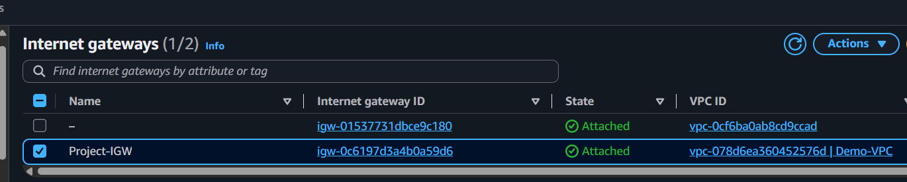
Note: Attaching an IGW alone does not provide internet access. Internet connectivity will be enabled after configuring the public route table.

Task 4: Create Public and Private Route Tables

Objective
Create separate route tables for the public and private subnets and associate each subnet with its respective route table.

Prerequisites
- AWS account with access to the N. Virginia (us-east-1) region.
- Demo-VPC created (Task 1 completed).
- Public-Subnet and Private-Subnet created (Task 2 completed).
- Project-IGW created and attached to Demo-VPC (Task 3 completed).

Implementation Steps

Part A: Create the Public Route Table
- Sign in to the AWS Management Console.
- Select the N. Virginia (us-east-1) region.
- Navigate to VPC → Route Tables.
- Click Create route table.
- Enter the following details:
  - Name: Public-RT
  - VPC: Demo-VPC
- Click Create route table.
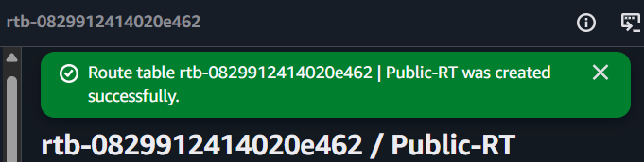
- Select Public-RT.
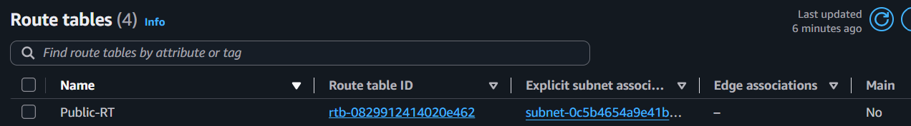
- Go to the Routes tab and click Edit routes.
- Click Add route and enter:
  - Destination: 0.0.0.0/0
  - Target: Internet Gateway → Project-IGW
- Save the changes.
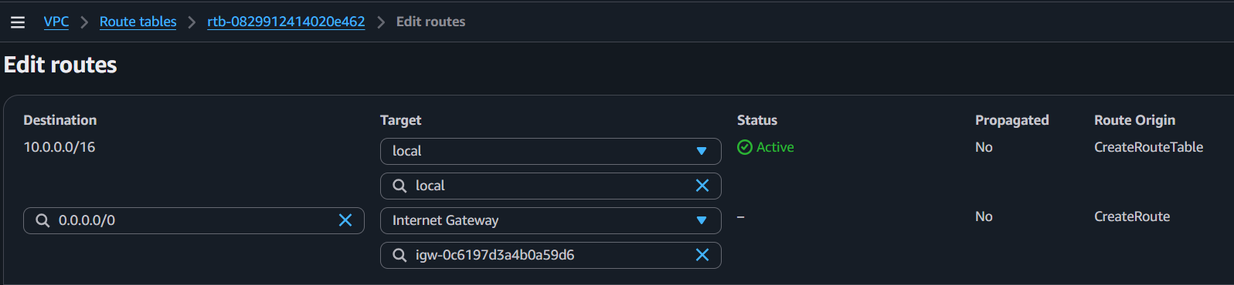
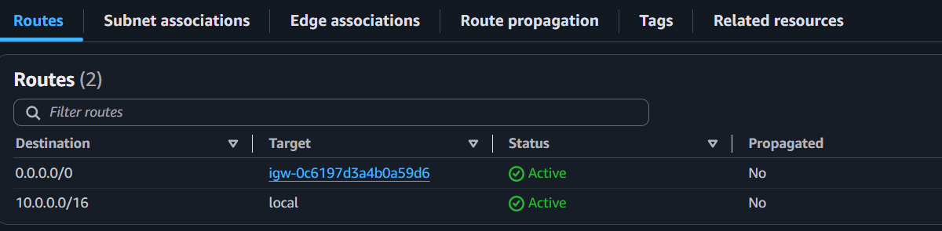
- Go to the Subnet Associations tab.
- Click Edit subnet associations.
- Select Public-Subnet.
- Click Save associations.
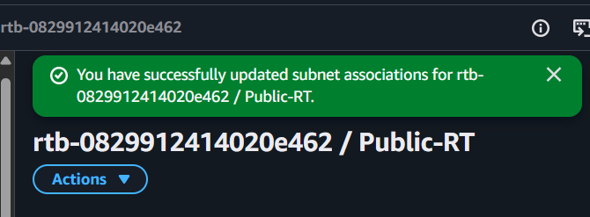

Part B: Create the Private Route Table
- Click Create route table.
- Enter the following details:
  - Name: Private-RT
  - VPC: Demo-VPC
- Click Create route table.
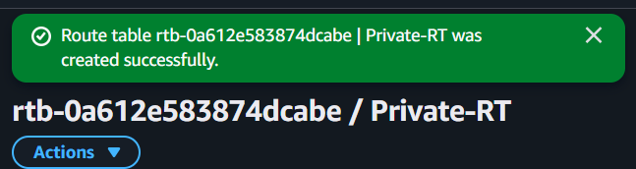
- Select Private-RT.
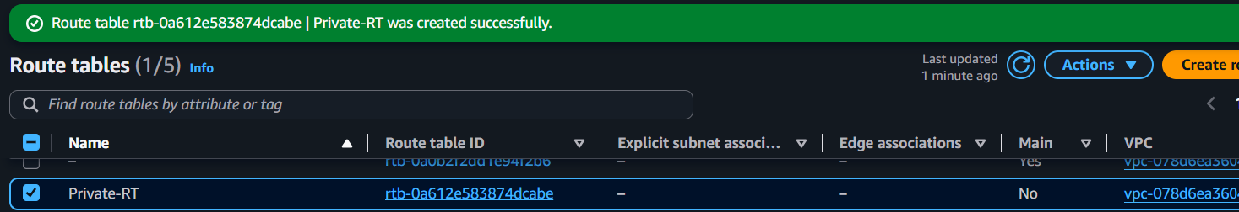
- Go to the Subnet Associations tab.
- Click Edit subnet associations.
- Select Private-Subnet.
- Click Save associations.
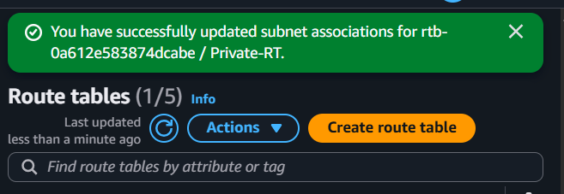
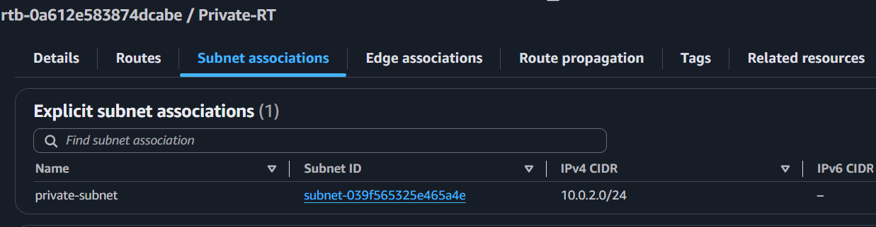

Expected Outcome
Public-RT is created and associated with Public-Subnet.
Public-RT contains a default route (0.0.0.0/0) pointing to Project-IGW.
Private-RT is created and associated with Private-Subnet.
Private-RT currently contains only the local route and will be updated with the NAT Gateway route in Task 5.

Task 5: Deploy a NAT Gateway and Configure Private Subnet Internet Access

Objective
Deploy a NAT Gateway in the public subnet and configure the private route table so that instances in the private subnet can access the internet without being directly accessible from the internet.

Prerequisites
- AWS account with access to the N. Virginia (us-east-1) region.
- Demo-VPC created (Task 1 completed).
- Public-Subnet and Private-Subnet created (Task 2 completed).
- Project-IGW attached to the VPC (Task 3 completed).
- Public-RT and Private-RT created (Task 4 completed).

Implementation Steps

Part A: Allocate an Elastic IP
- Sign in to the AWS Management Console.
- Navigate to VPC → Elastic IPs.
- Click Allocate Elastic IP address.
- Leave the default settings and click Allocate.
- Note the allocated Elastic IP.
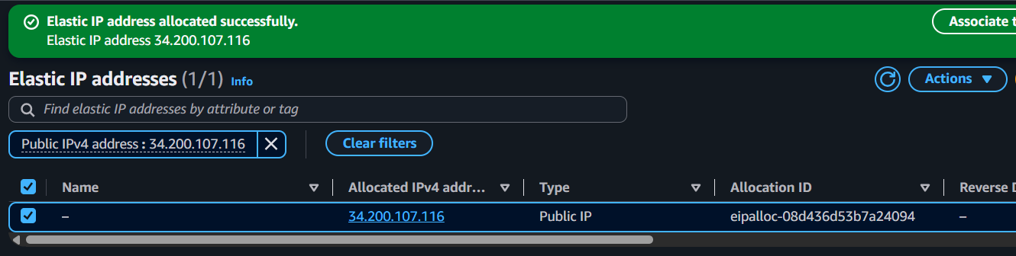

Part B: Create the NAT Gateway
- Navigate to VPC → NAT Gateways.
- Click Create NAT Gateway.
- Enter the following details:
  - Name: Project-NAT-GW
  - Subnet: Public-Subnet
  - Connectivity Type: Public
  - Elastic IP: Select the allocated Elastic IP.
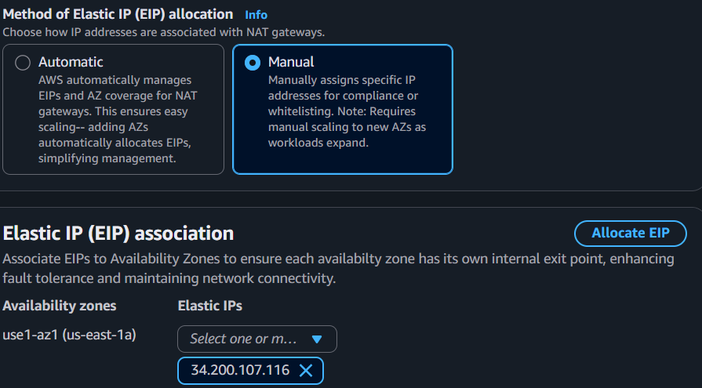
- Click Create NAT Gateway.
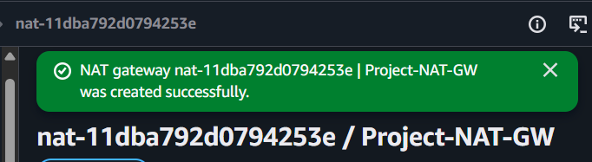
- Wait until the NAT Gateway status changes to Available.
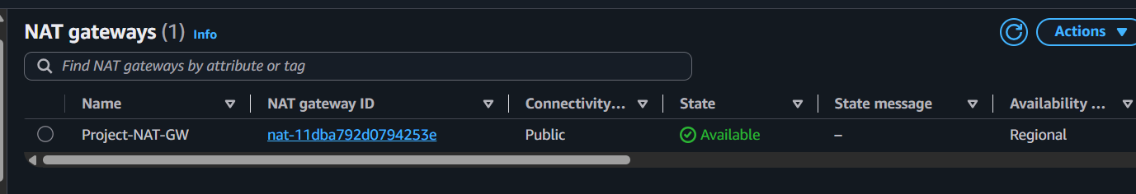

Part C: Update the Private Route Table
- Navigate to VPC → Route Tables.
- Select Private-RT.
- Go to the Routes tab.
- Click Edit routes.
- Click Add route and enter:
  - Destination: 0.0.0.0/0
  - Target: Project-NAT-GW
- Click Save changes.
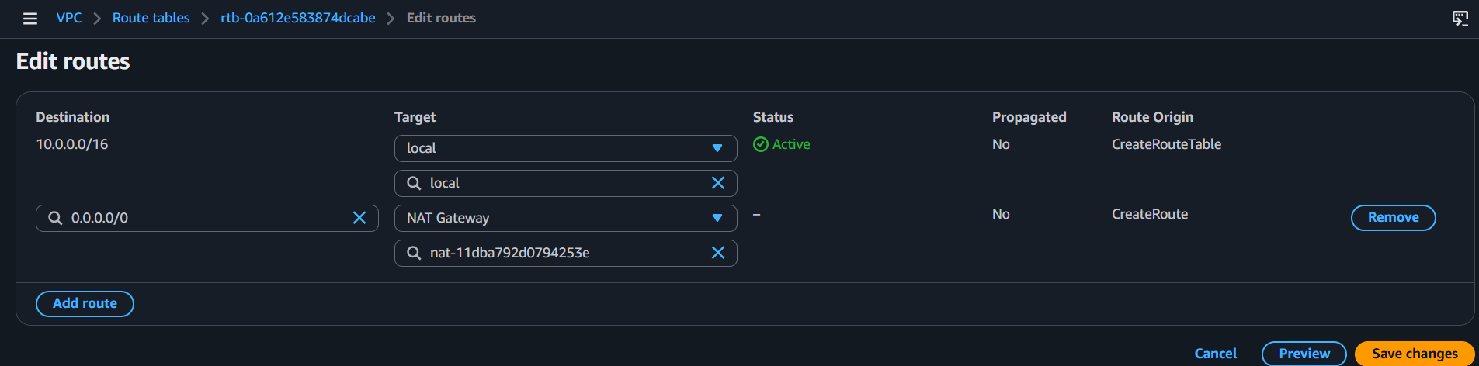

Expected Outcome
- A NAT Gateway named Project-NAT-GW is created in the Public-Subnet.
- An Elastic IP is associated with the NAT Gateway.
- Private-RT contains a default route (0.0.0.0/0) pointing to Project-NAT-GW.
- Instances launched in the Private-Subnet can access the internet for updates and package installations while remaining inaccessible directly from the internet.
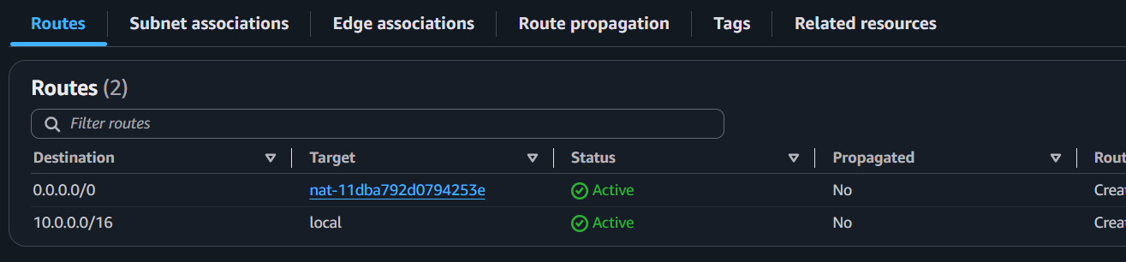

Task 6: Launch Two EC2 Instances (One in Public Subnet and One in Private Subnet)

Objective
Launch two EC2 instances, one in the Public-Subnet and one in the Private-Subnet, to host the Apache web server in the subsequent task.

Prerequisites
- AWS account with access to the N. Virginia (us-east-1) region.
- Demo-VPC created (Task 1 completed).
- Public-Subnet and Private-Subnet created (Task 2 completed).
- Internet Gateway attached (Task 3 completed).
- Public and Private Route Tables configured (Task 4 completed).
- NAT Gateway configured (Task 5 completed).
- An existing EC2 Key Pair.
- A Security Group allowing:
  - SSH (Port 22)
  - HTTP (Port 80)

Implementation Steps

Part A: Launch the Public EC2 Instance
- Sign in to the AWS Management Console.
- Navigate to EC2 → Instances.
- Click Launch Instance.
- Enter the following details:
  - Name: Public-EC2
  - AMI: Amazon Linux 2023
  - Instance Type: t3.micro
  - Key Pair: Select your existing key pair.
- Under Network Settings:
  - VPC: Demo-VPC
  - Subnet: Public-Subnet
  - Auto-assign Public IP: Enable
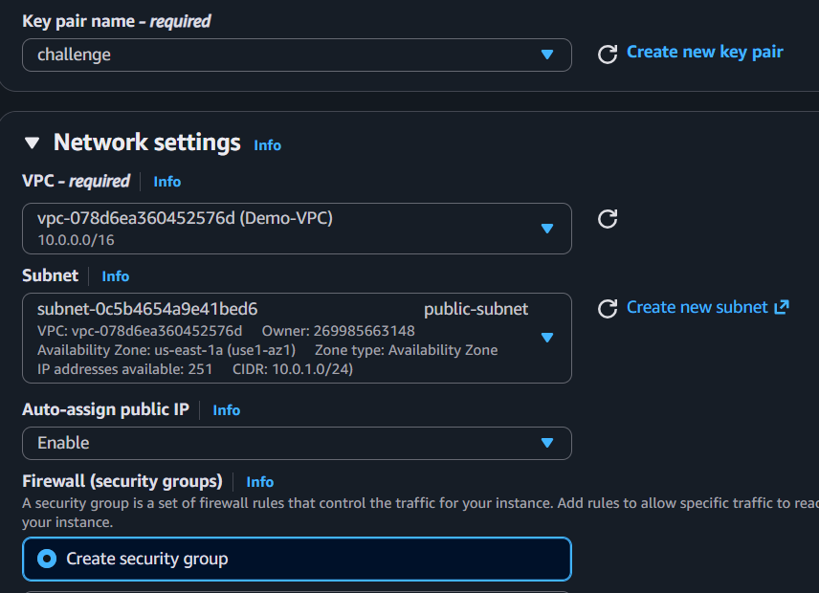
  - Security Group: Select the existing security group (allowing SSH and HTTP).
- Click Launch Instance.
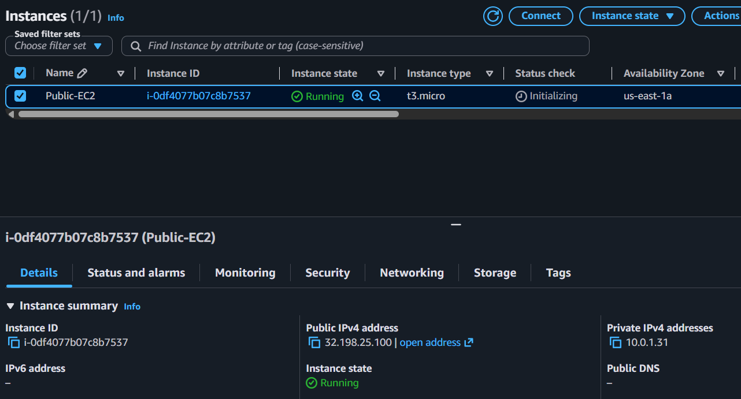
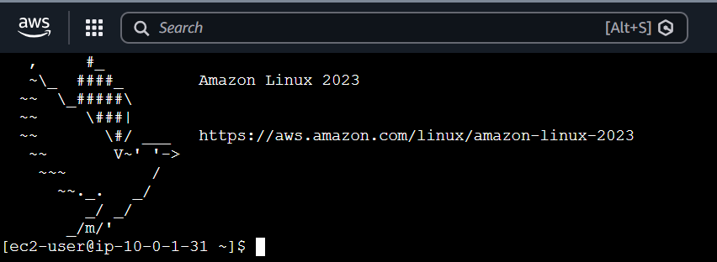

Part B: Launch the Private EC2 Instance
- Click Launch Instance again.
- Enter the following details:
  - Name: Private-EC2
  - AMI: Amazon Linux 2023
  - Instance Type: t3.micro
  - Key Pair: Select your existing key pair.
- Under Network Settings:
  - VPC: Demo-VPC
  - Subnet: Private-Subnet
  - Auto-assign Public IP: Disable
  - Security Group: Select the same security group (or another appropriate security group allowing SSH and HTTP).
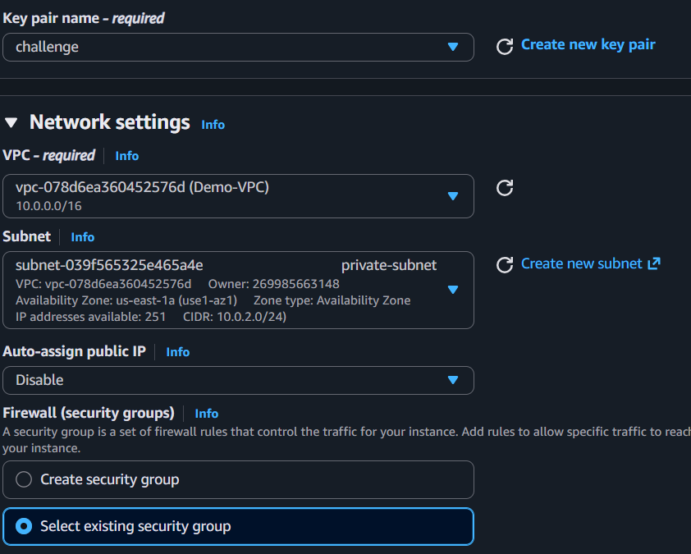
  - Add userdata
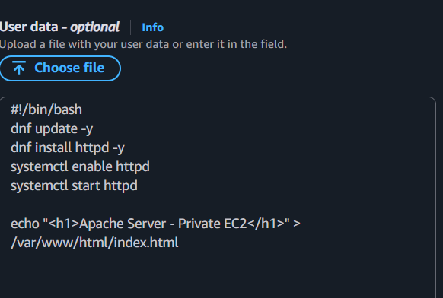
- Click Launch Instance.
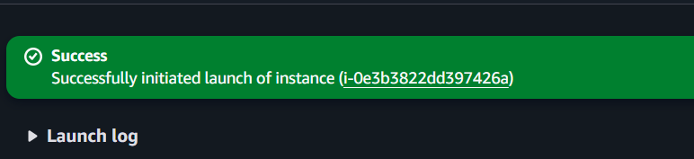
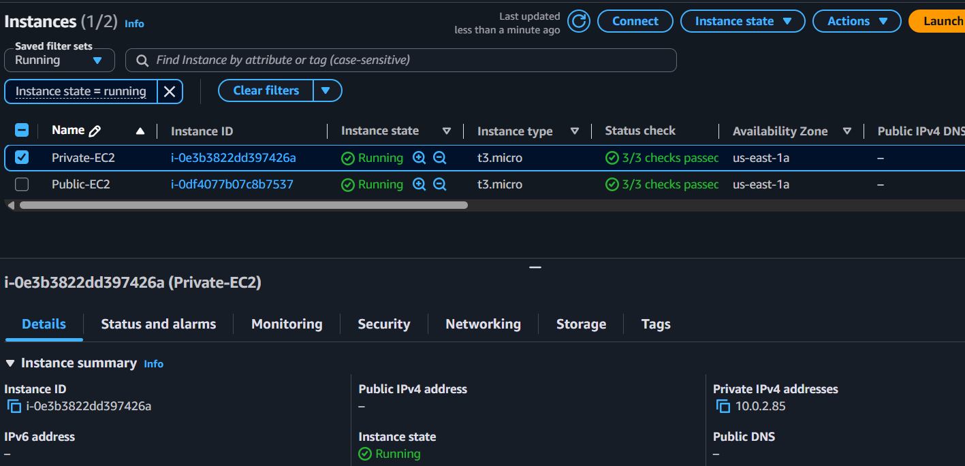

Expected Outcome
- Public-EC2 is launched in the Public-Subnet with a Public IPv4 address.
- Private-EC2 is launched in the Private-Subnet without a Public IPv4 address.
- Both instances are in the Running state and are ready for Apache installation in Task 7.

Task 7: Deploy Apache Server on Both EC2 Instances with a Sample index.html File

Objective
Install and configure the Apache web server on both the Public-EC2 and Private-EC2 instances, and deploy a sample index.html page to verify web server functionality.

Prerequisites
- AWS account with access to the N. Virginia (us-east-1) region.
- Public-EC2 and Private-EC2 instances are running (Task 6 completed).
- SSH access to the Public-EC2 instance.
- Connectivity to the Private-EC2 instance (via a Bastion Host, SSH Proxy, or AWS Systems Manager Session Manager).
- Security Group allowing HTTP (Port 80).

Implementation Steps

Part A: Install Apache on Public-EC2
- Connect to Public-EC2 using SSH.
- Run the following commands:
sudo dnf update -y
sudo dnf install httpd -y
sudo systemctl enable httpd
sudo systemctl start httpd
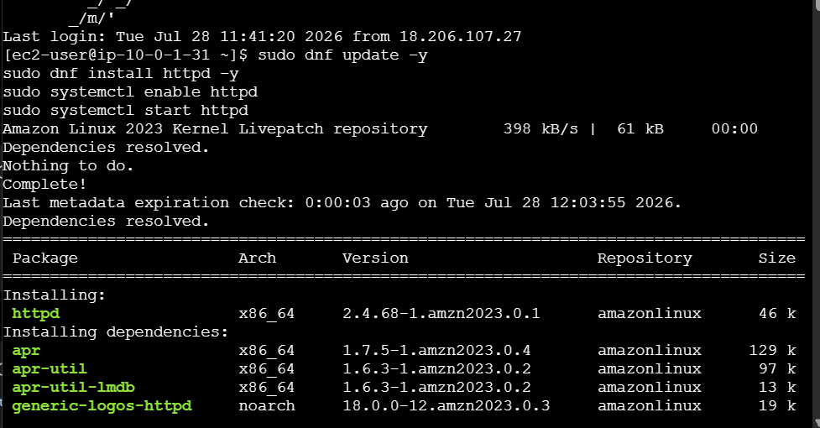
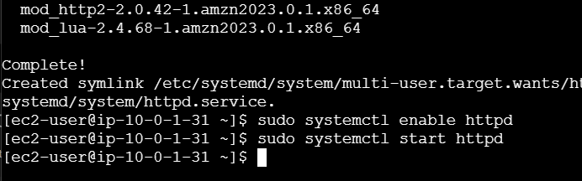
- Create a sample web page:
echo "<h1>Apache Server - Public EC2</h1>" | sudo tee /var/www/html/index.html
- Verify Apache status:
sudo systemctl status httpd
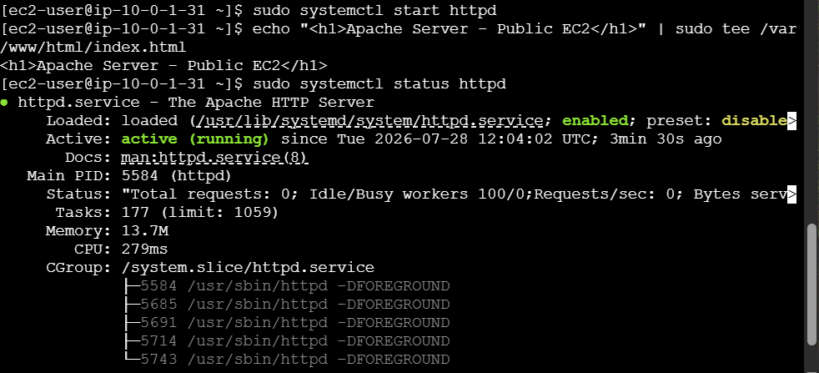

5. Access with public ip in browser
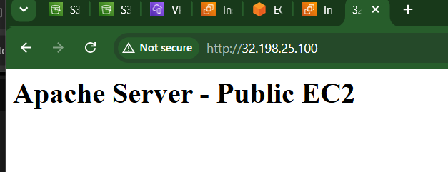

Part B: Install Apache on Private-EC2
- Connect to Private-EC2.
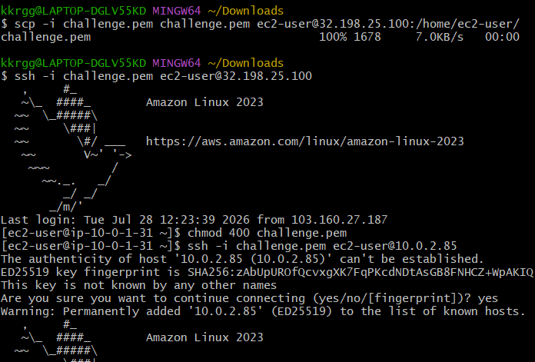
2. Verify Apache status:
sudo systemctl status httpd
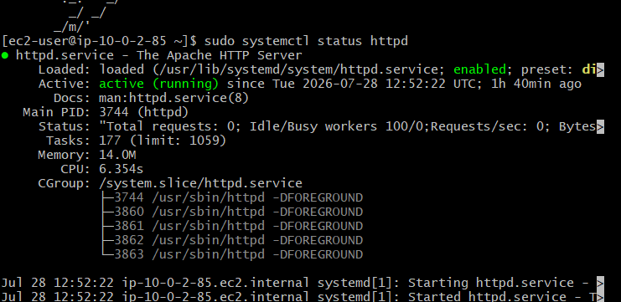
3. Once status is running, verify Apache: “curl http://localhost”
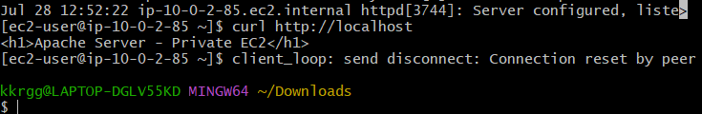

Expected Outcome
- Apache (httpd) is installed and running on both EC2 instances.
- Apache service is enabled to start automatically on system boot.
- The sample index.html file is deployed on both instances.
- Accessing the Public-EC2 public IP from a browser displays:
Apache Server - Public EC2


Task 8: Create an Application Load Balancer and Attach Both EC2 Instances

Objective
Create an Application Load Balancer (ALB) to distribute incoming HTTP traffic across the Public-EC2 and Private-EC2 instances.

Prerequisites
- AWS account with access to the N. Virginia (us-east-1) region.
- Demo-VPC with public and private subnets.
- Internet Gateway and NAT Gateway configured.
- Public-EC2 and Private-EC2 are running.
- Apache is installed and running on both EC2 instances.
- Security Group allows HTTP (Port 80).

Implementation Steps

Part A: Create a Target Group
- Go to EC2 Console → Target Groups.
- Click Create target group.
- Configure the following:
  - Target type: Instances
  - Target group name: Apache-TG
  - Protocol: HTTP
  - Port: 80
  - VPC: Demo-VPC
- Click Next.
- Select both:
  - Public-EC2
  - Private-EC2
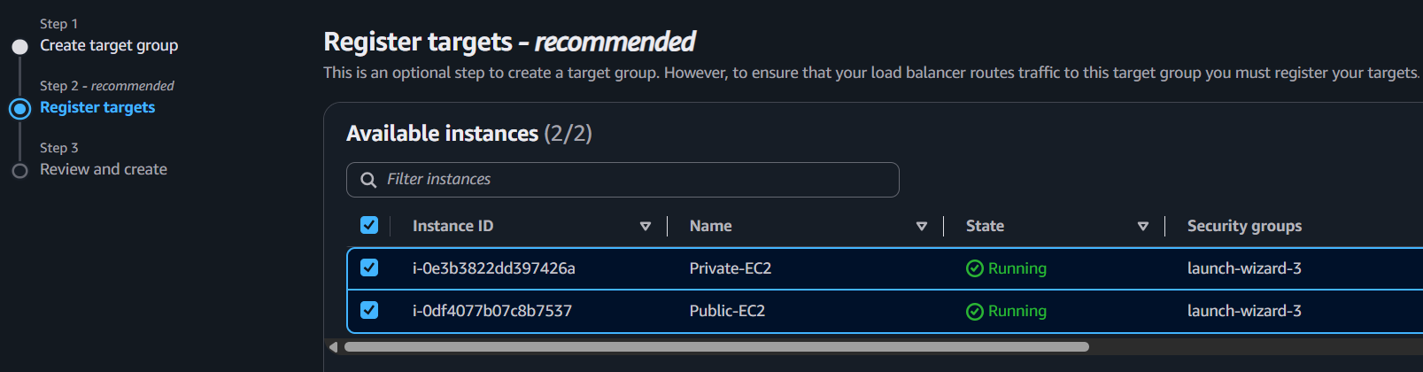
- Click Include as pending below.
- Click Create target group.
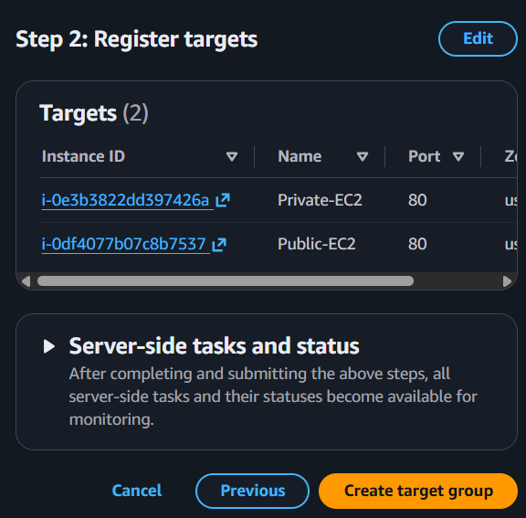
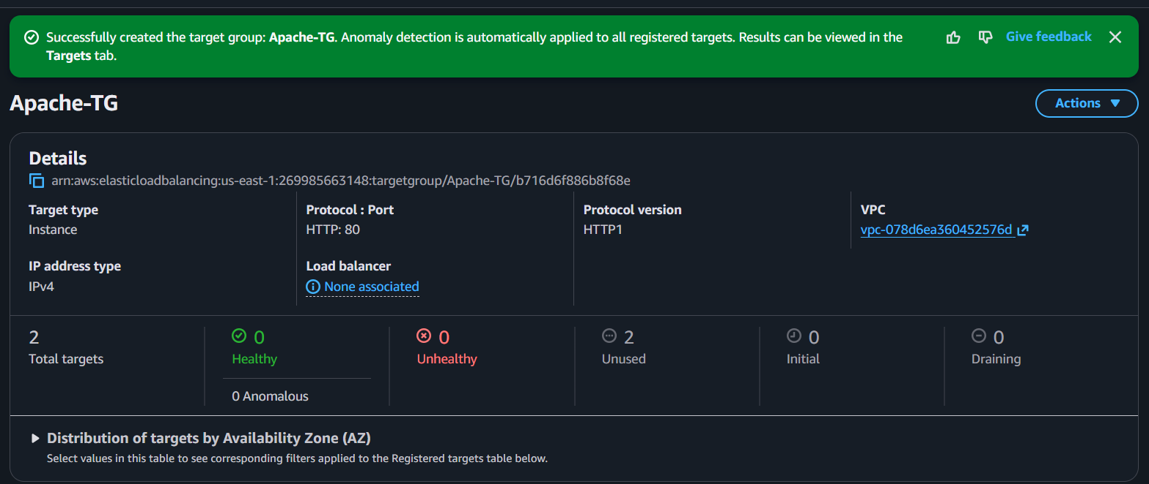

Part B: Create the Application Load Balancer
- Go to EC2 Console → Load Balancers.
- Click Create Load Balancer.
- Select Application Load Balancer.
- Configure the following:
  - Name: Apache-ALB
  - Scheme: Internet-facing
  - IP address type: IPv4
- Under Network mapping:
  - VPC: Demo-VPC
  - Availability Zone: Select us-east-1a
  - Select Public-Subnet
- Under Security Groups:
  - Select a security group allowing HTTP (Port 80).
- Under Listeners and routing:
  - Protocol: HTTP
  - Port: 80
  - Default action: Forward to Apache-TG
- Click Create Load Balancer.
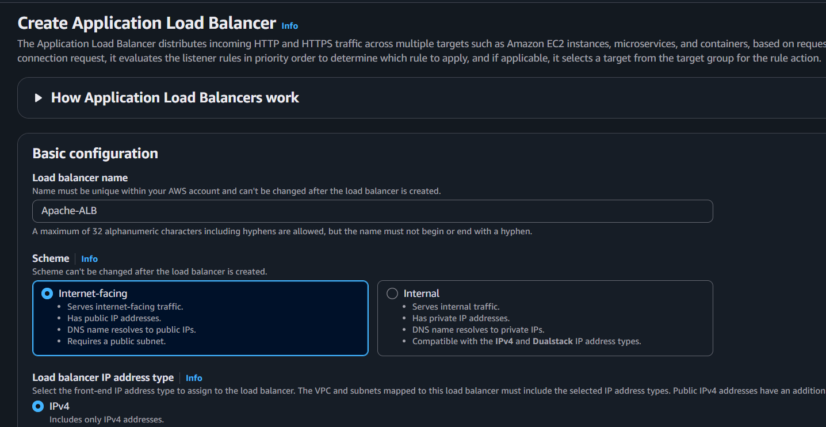
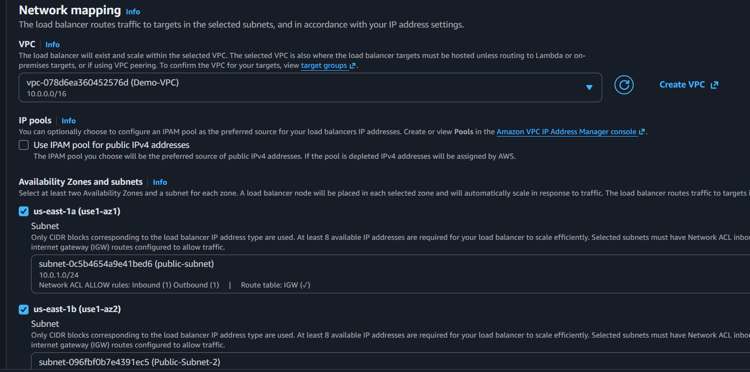
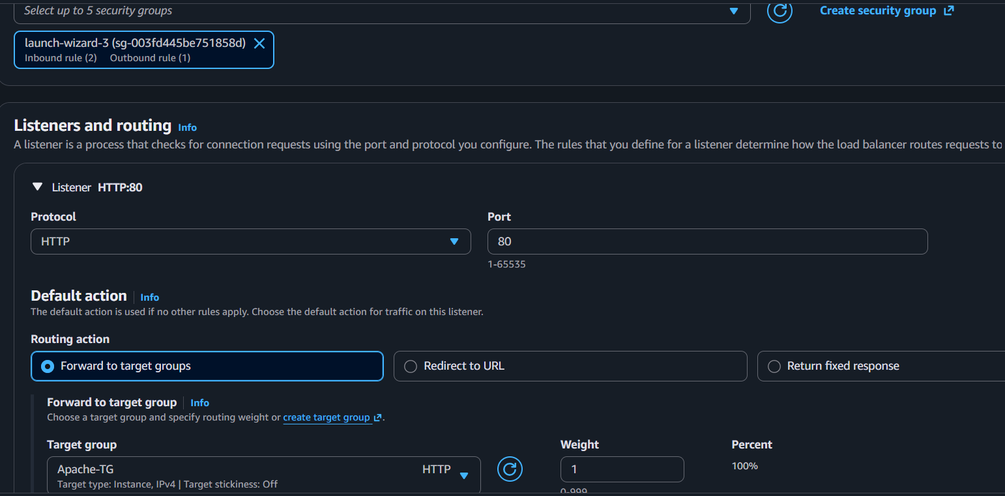
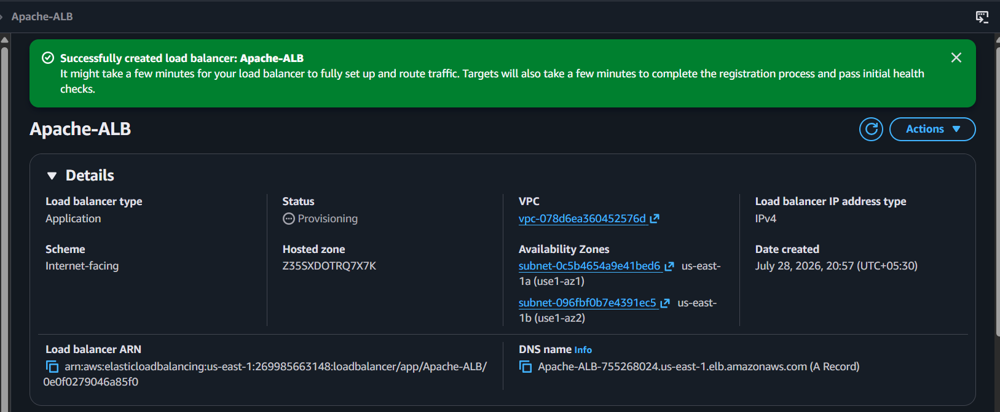
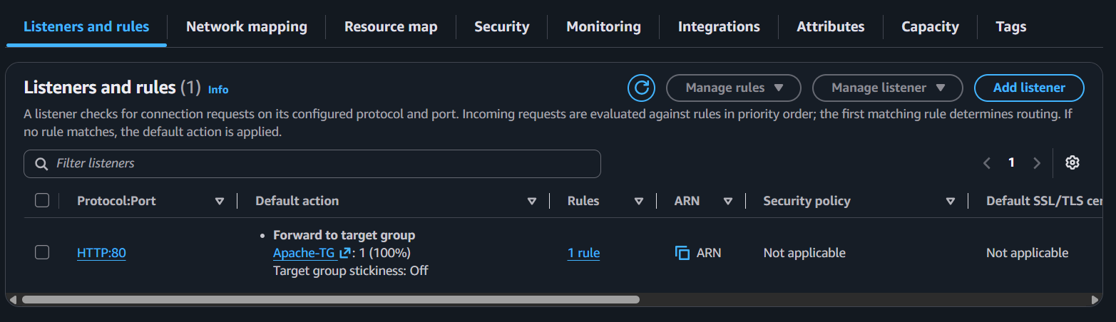

Part C: Verify Target Health
- Go to EC2 Console → Target Groups.
- Select Apache-TG.
- Open the Targets tab.
- Wait 2–5 minutes.
- Verify that both instances show:
Healthy
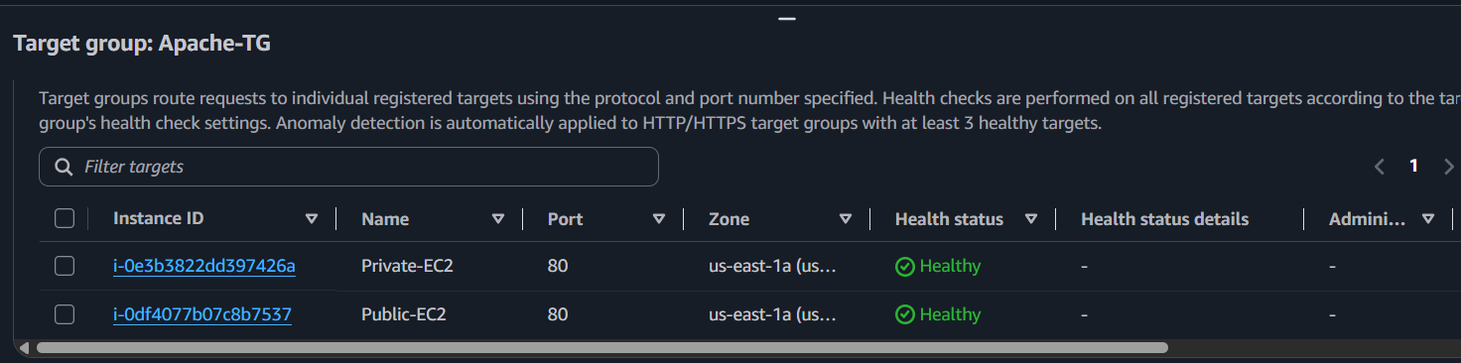

Part D: Test the Load Balancer
- Go to EC2 Console → Load Balancers.
- Select Apache-ALB.
- Copy the DNS name.
- Open a browser and access:
http://<ALB-DNS-Name>
- Refresh the page multiple times.
If you've configured different index.html pages on each EC2 instance, you should see responses from both servers as traffic is distributed.
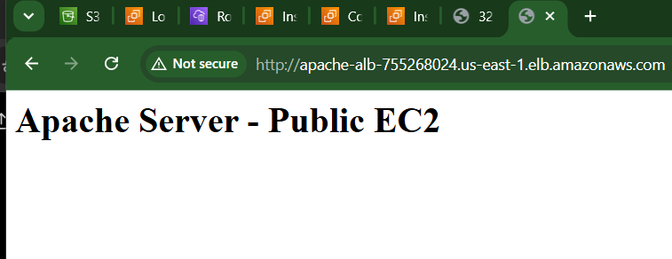
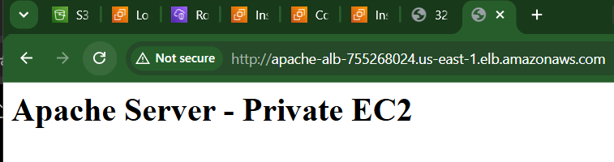

Expected Outcome
- Application Load Balancer Apache-ALB is created.
- Target Group Apache-TG contains both EC2 instances.
- Both EC2 instances display Healthy status.
- Accessing the ALB DNS name in a browser successfully loads the Apache web page from the registered EC2 instances.

Task 9: Store Application Load Balancer Access Logs in Amazon S3

Objective
Configure the Application Load Balancer (ALB) to store its access logs in an Amazon S3 bucket for monitoring, auditing, and troubleshooting.

Prerequisites
- AWS account with access to the N. Virginia (us-east-1) region.
- Application Load Balancer (Apache-ALB) created (Task 8 completed).
- An S3 bucket to store ALB access logs.
- Permissions to update the ALB attributes and S3 bucket policy.

Implementation Steps

Part A: Create an S3 Bucket
- Go to S3 Console.
- Click Create bucket.
- Configure the following:
  - Bucket name: apache-alb-logs-<unique-name>
  - Region: N. Virginia (us-east-1)
- Leave the remaining settings as default.
- Click Create bucket.
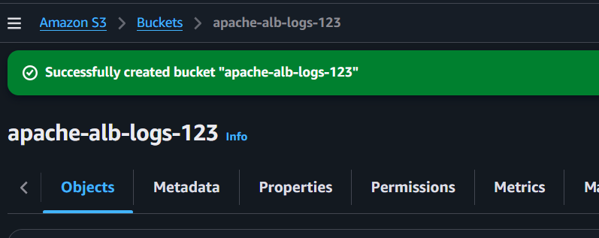

Part B: Add the Required Bucket Policy
- Open the newly created S3 bucket.
- Go to the Permissions tab.
- Under Bucket Policy, click Edit.
- Add the bucket policy that allows the ALB service to write access logs.
- Save the policy.
Replace:
- <bucket-name> with your S3 bucket name.
- <AWS-Account-ID> with your AWS account ID.
{
"Version": "2012-10-17",
"Statement": [
{
"Sid": "AWSLogDeliveryWrite",
"Effect": "Allow",
"Principal": {
"Service": "logdelivery.elasticloadbalancing.amazonaws.com"
},
"Action": "s3:PutObject",
"Resource": "arn:aws:s3:::<bucket-name>/AWSLogs/<AWS-Account-ID>/*"
}
]
}
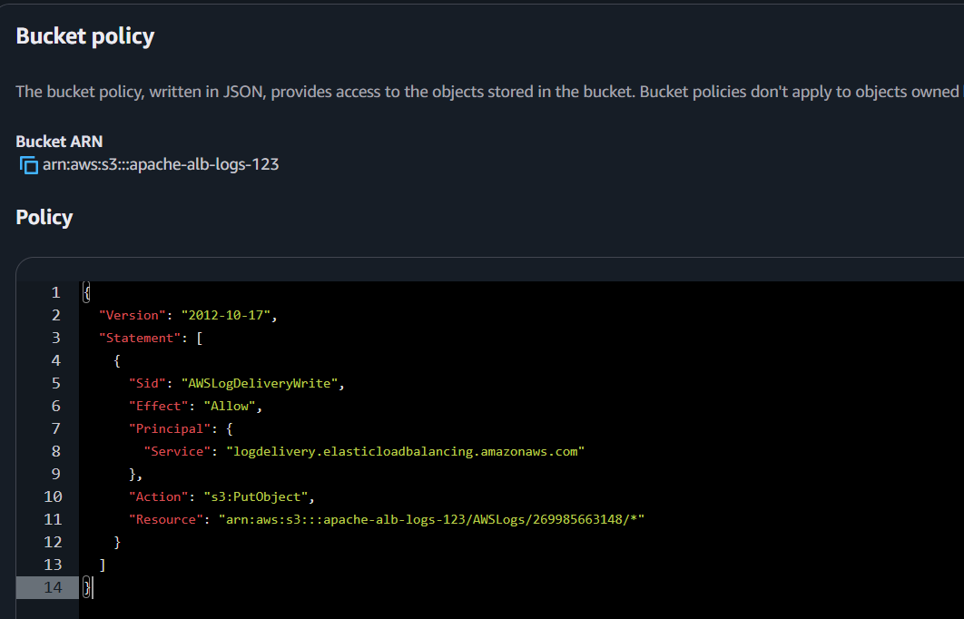

Part C: Enable Access Logs on the ALB
- Go to EC2 Console → Load Balancers.
- Select Apache-ALB.
- Open the Attributes tab.
- Click Edit.
- Under Access logs:
  - Enable Access logs.
  - Select the S3 bucket created in Part A.
  - (Optional) Specify a prefix such as alb-logs/.
- Click Save changes.
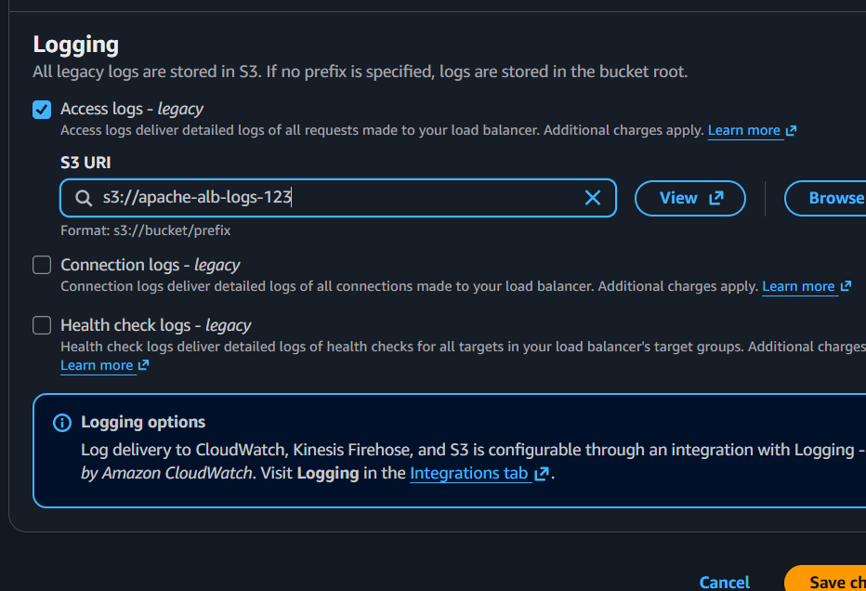

Part D: Generate Traffic
- Copy the DNS name of the ALB.
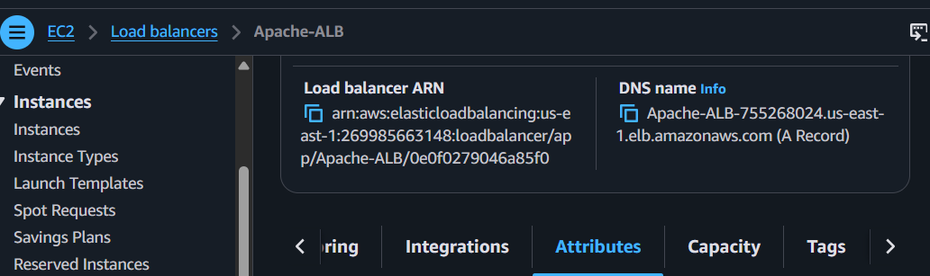
- Open it in a web browser.
- Refresh the page several times to generate HTTP requests.
- Wait a few minutes for the logs to be delivered.
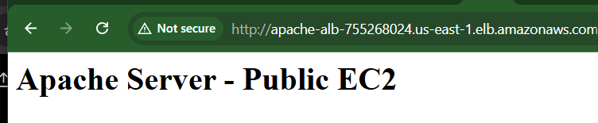
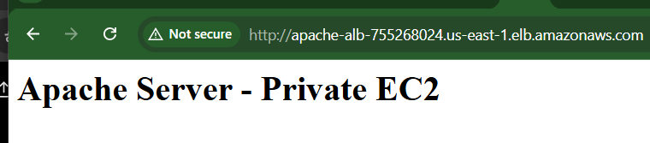

Part E: Verify Logs
- Go to S3 Console.
- Open your bucket.
- Navigate to:
AWSLogs/<AWS-Account-ID>/
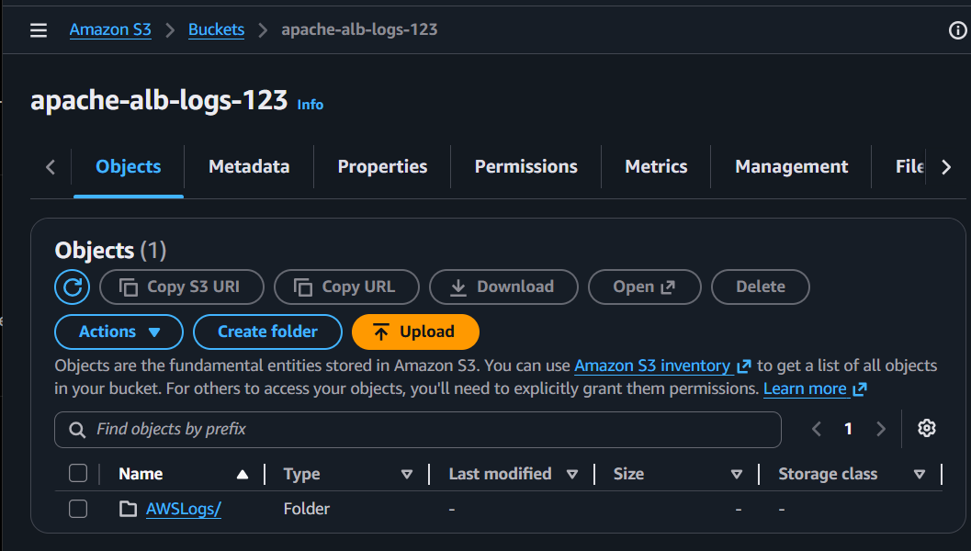
- Verify that ALB log files are present.
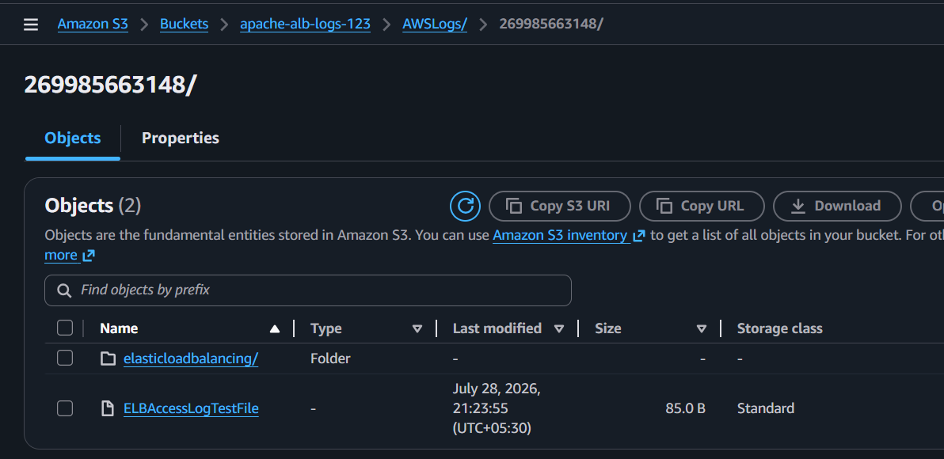

Expected Outcome
- An S3 bucket is created to store ALB access logs.
- Access logging is enabled on Apache-ALB.
- ALB access log files are successfully delivered to the S3 bucket after traffic is generated.
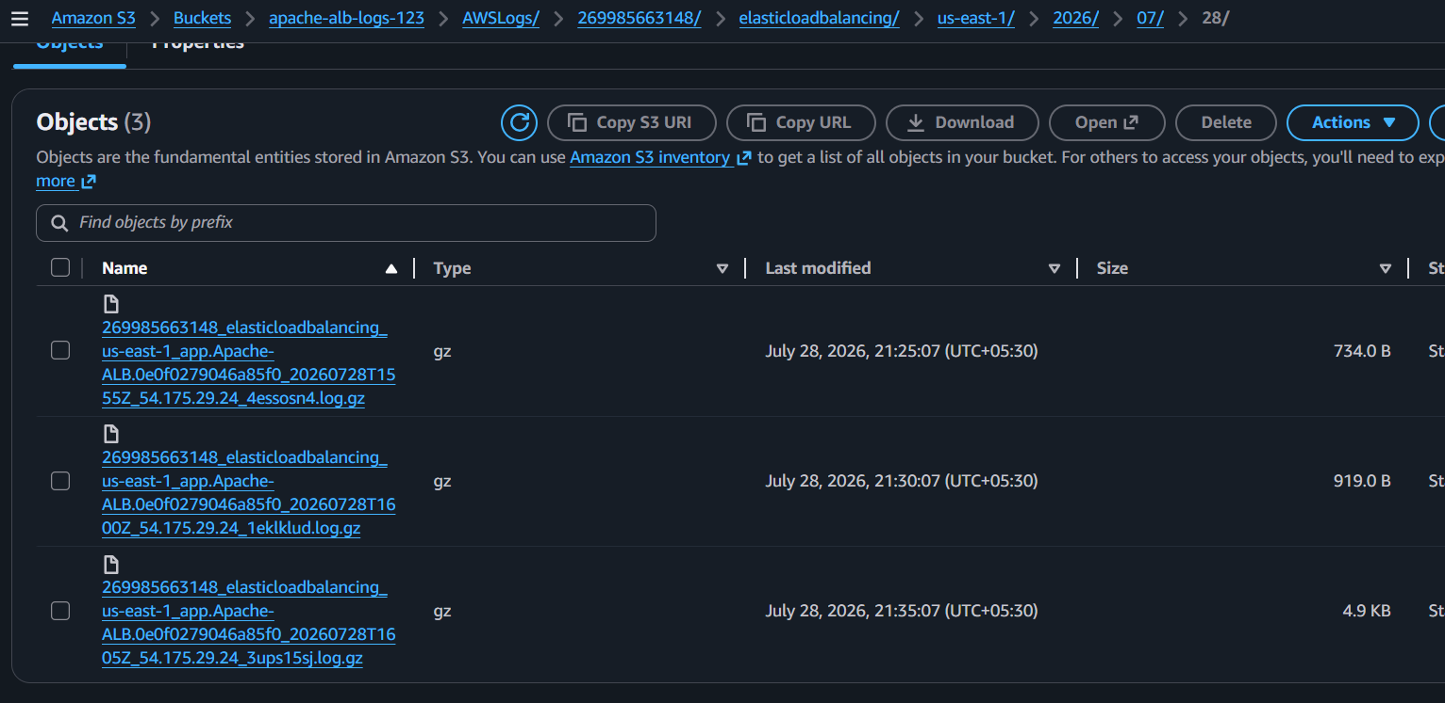

Task 10: Store VPC Flow Logs in a CloudWatch Log Group

Objective
Create a VPC Flow Log to capture network traffic information for Project-VPC and store the logs in an Amazon CloudWatch Log Group.

Prerequisites
- AWS account with access to the N. Virginia (us-east-1) region.
- Demo-VPC created.
- Permission to create CloudWatch Log Groups, IAM Roles, and VPC Flow Logs.

Implementation Steps

Part A: Create a CloudWatch Log Group
- Go to CloudWatch Console.
- In the left navigation pane, click Log groups.
- Click Create log group.
- Enter:
  - Log group name: VPC-FlowLogs
- Click Create.
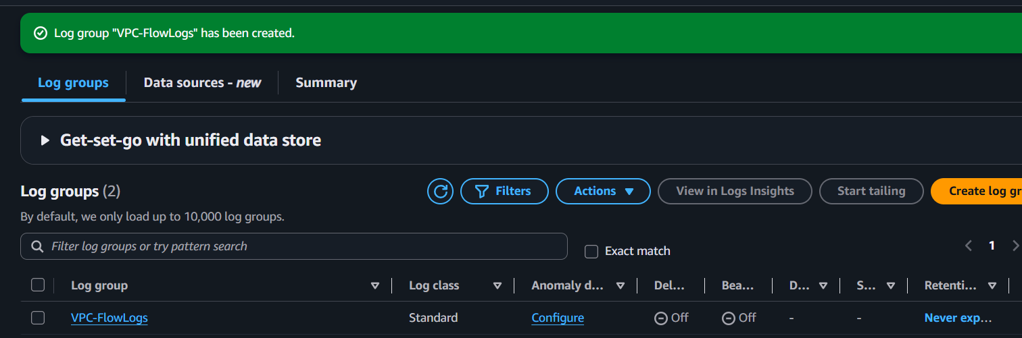

Part B: Create an IAM Role for VPC Flow Logs
- Go to VPC Console → Your VPCs.
- Select Demo-VPC.
- Go to the Flow Logs tab.
- Click Create flow log.
- Configure:
  - Name: Project-VPC-FlowLog
  - Filter: All
  - Maximum aggregation interval: 1 minute
  - Destination: Send to CloudWatch Logs
  - Log group: VPC-FlowLogs
- Under IAM Role, click Set up permissions.
- AWS will create the required IAM role automatically.
- Return to the Create flow log page and select the newly created IAM role.
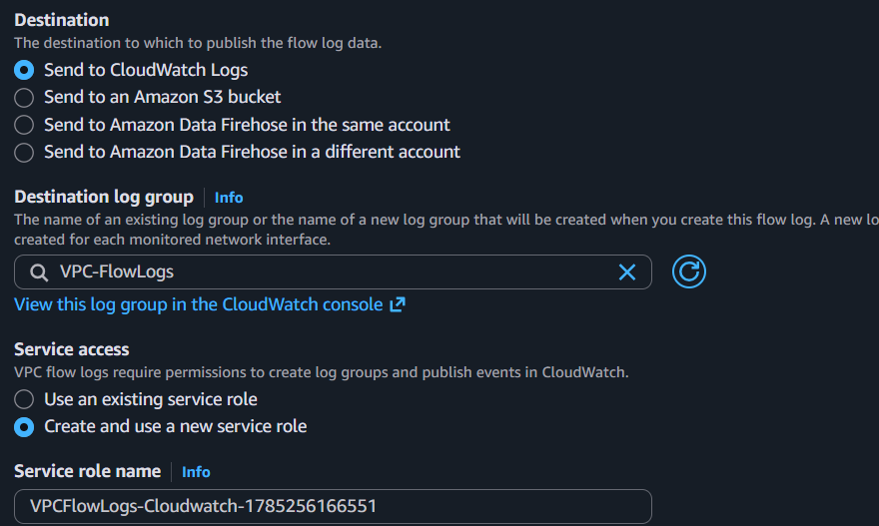

Part C: Create the Flow Log
- Verify all settings.
- Click Create flow log.
- Wait a few minutes for the flow log to become Active.
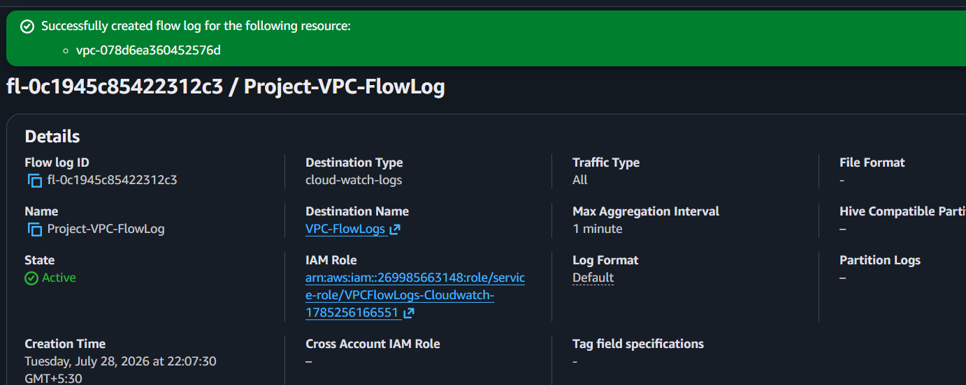

Part D: Generate Network Traffic
Generate some traffic by:
- Opening the ALB DNS name in your browser several times.
- SSH into the Public EC2.
- Run:
ping 8.8.8.8 -c 5
or
curl http://example.com
This generates network traffic that the VPC Flow Log can capture.
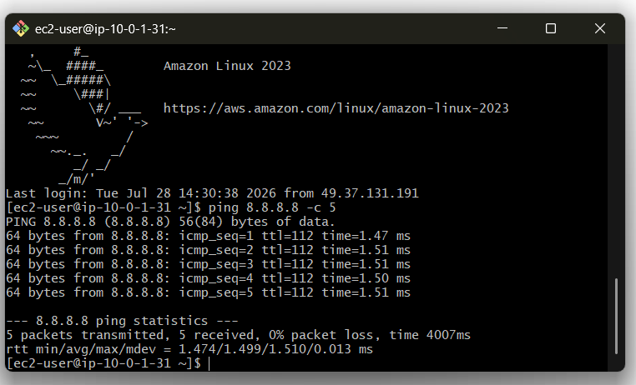

Part E: Verify Flow Logs
- Go to CloudWatch Console.
- Open Log groups.
- Select VPC-FlowLogs.
- Open the available Log Stream.
- Verify that flow log entries are being generated.
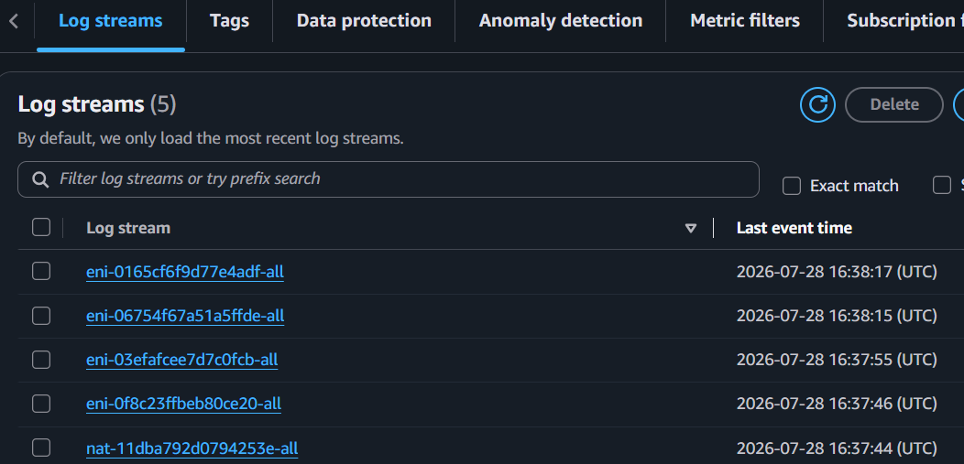
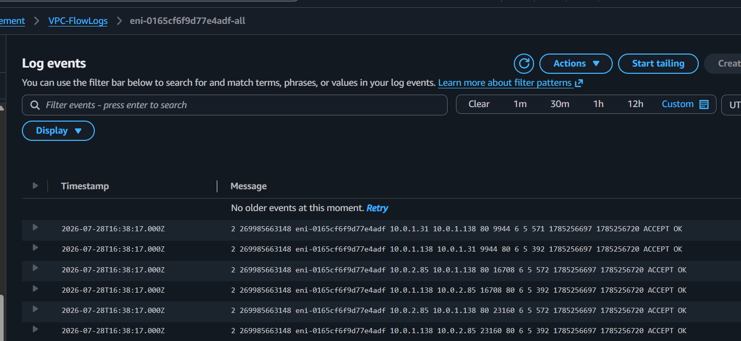

Expected Outcome
- A CloudWatch Log Group named VPC-FlowLogs is created.
- A VPC Flow Log named Project-VPC-FlowLog is attached to Demo-VPC.
- Network traffic records are successfully stored in the VPC-FlowLogs CloudWatch Log Group.

Task 11: Create CloudWatch Dashboards to Monitor CPU Utilization and Apache Service

Objective
Create a CloudWatch dashboard to monitor:
- CPU Utilization of the EC2 instances.
- Apache (httpd) service status using the CloudWatch Agent.

Prerequisites
- AWS account with access to the N. Virginia (us-east-1) region.
- Public-EC2 and Private-EC2 are running.
- Apache is installed and running on both EC2 instances.
- IAM role attached to both EC2 instances with the CloudWatchAgentServerPolicy policy.

Implementation Steps

Part A: Attach IAM Role to EC2 Instances
- Go to IAM → Roles.
- Click Create role.
- Select AWS service → EC2.
- Attach the policy:
  - CloudWatchAgentServerPolicy
- Name the role:
  - EC2-CloudWatch-Role
- Create the role.
- Go to EC2 → Instances.
- Select Public-EC2.
- Click Actions → Security → Modify IAM Role.
- Attach EC2-CloudWatch-Role. |
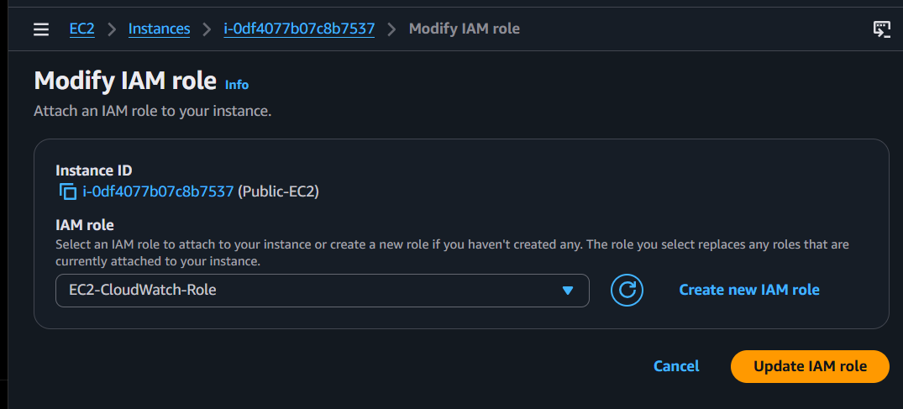
- Repeat for Private-EC2.
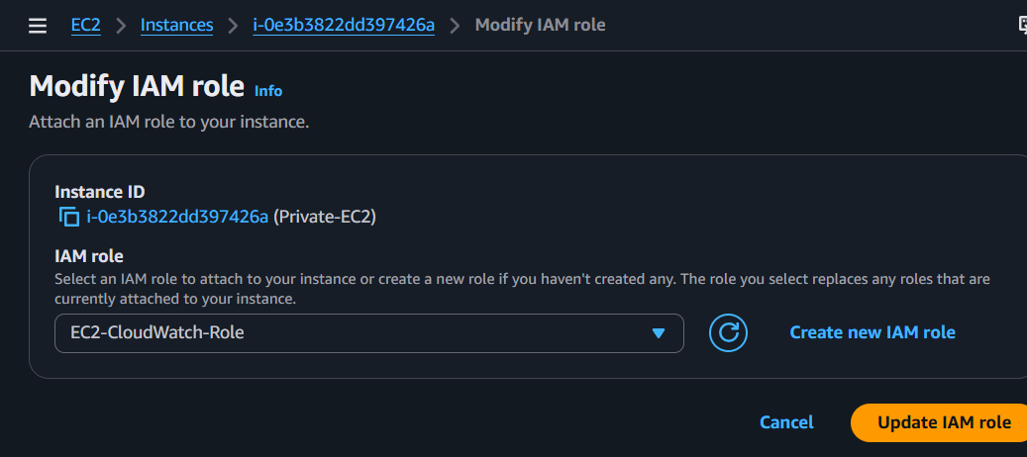

Part B: Install the CloudWatch Agent
Connect to each EC2 instance and run:
sudo dnf install amazon-cloudwatch-agent -y
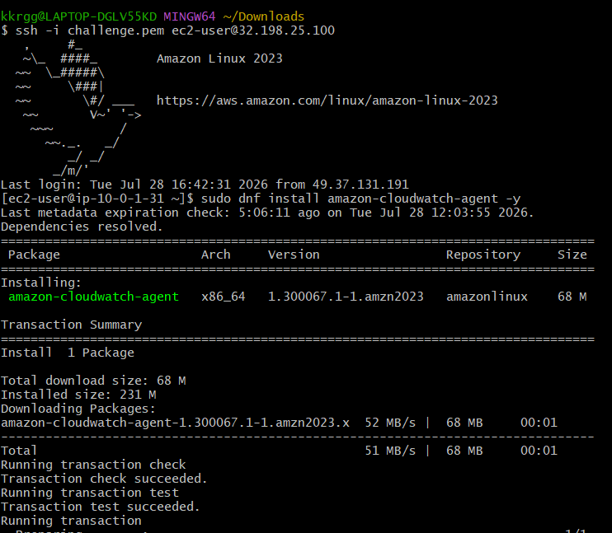

Part C: Create the CloudWatch Agent Configuration
Run:
sudo /opt/aws/amazon-cloudwatch-agent/bin/amazon-cloudwatch-agent-config-wizard
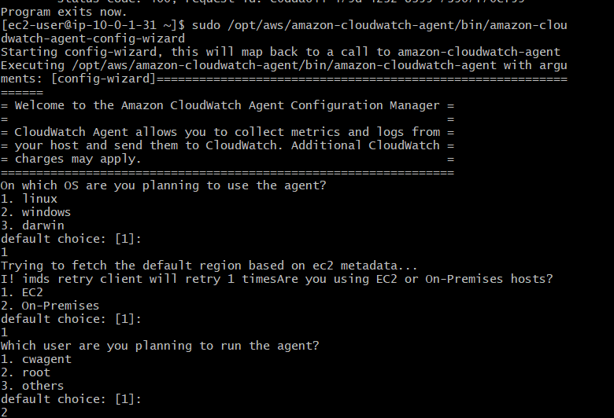
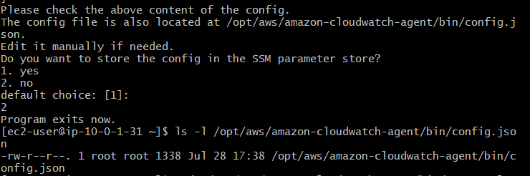
When prompted, configure it to monitor:
- CPU metrics
- Process metrics (procstat)
- Process name:
httpd
Save the configuration.

Part D: Start the CloudWatch Agent
Run:
sudo /opt/aws/amazon-cloudwatch-agent/bin/amazon-cloudwatch-agent-ctl \
-a fetch-config \
-m ec2 \
-c file:/opt/aws/amazon-cloudwatch-agent/etc/amazon-cloudwatch-agent.json \
-s
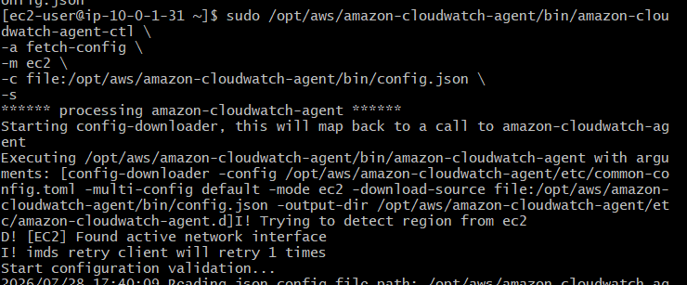
Verify the agent:
sudo systemctl status amazon-cloudwatch-agent
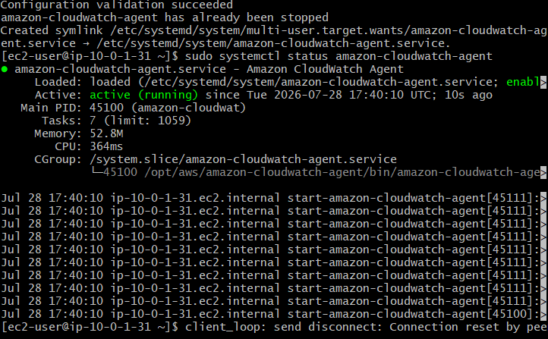

Part E: Create the CloudWatch Dashboard
- Go to CloudWatch → Dashboards.
- Click Create dashboard.
- Enter:
  - Dashboard Name: EC2-Monitoring
- Click Create dashboard.

Part F: Add CPU Utilization Widget
- Click Add widget.
- Select Line.
- Choose:
  - EC2
  - Per-Instance Metrics
  - CPUUtilization
- Select:
  - Public-EC2
  - Private-EC2
- Click Create widget.
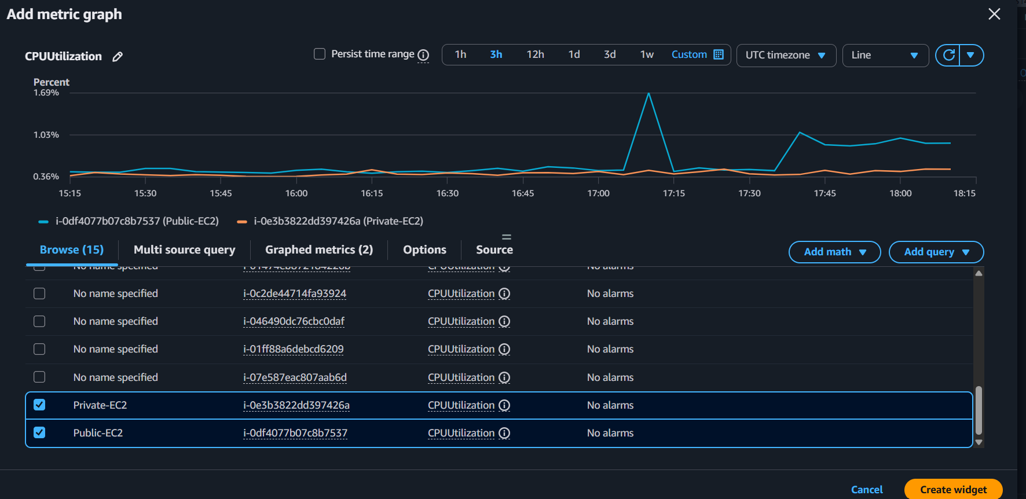
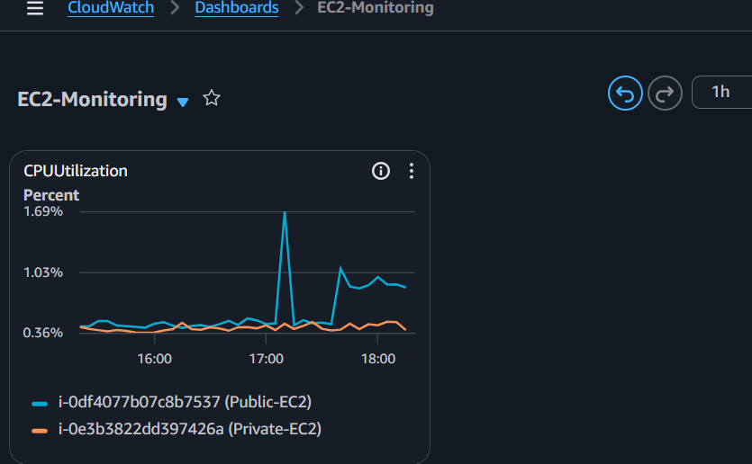

Part G: Add Apache Service Widget
- Click Add widget.
- Select Line.
- Choose namespace:
CWAgent
- Select the metric:
procstat_lookup_pid_count
or
procstat_cpu_time
- Select the process:
httpd
- Add the widget.
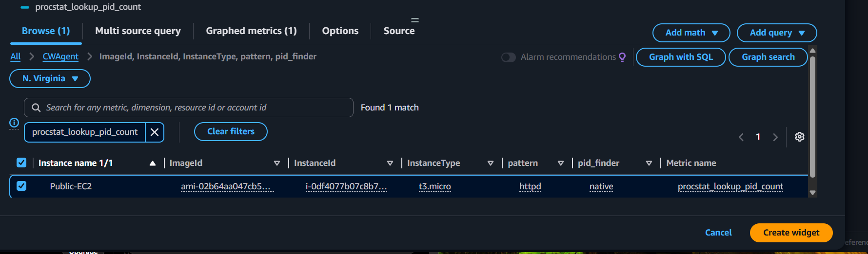
- Save the dashboard.
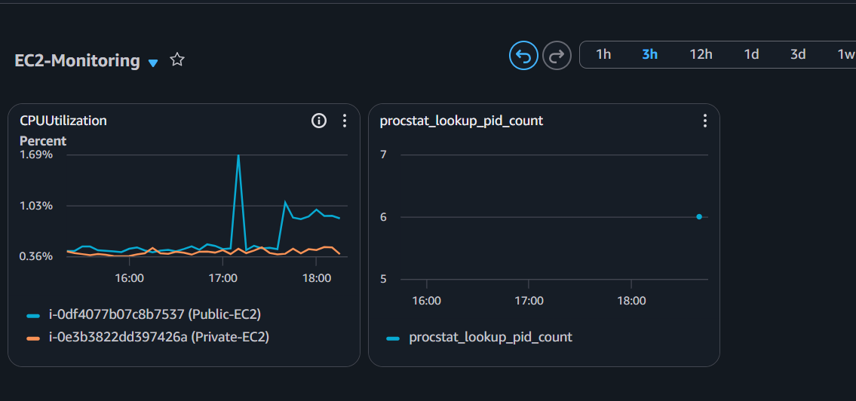

Expected Outcome
- A CloudWatch dashboard named EC2-Monitoring is created.
- CPU Utilization is displayed for both EC2 instances.
- Apache (httpd) service metrics are displayed using the CloudWatch Agent.
- The dashboard updates automatically with the latest metrics.

Task 12: Configure Auto Scaling Based on CPU Utilization

Objective
Configure an Auto Scaling Group (ASG) to automatically launch a new EC2 instance when the average CPU utilization exceeds 70%.

Prerequisites
- AWS account with access to the N. Virginia (us-east-1) region.
- Application Load Balancer (Apache-ALB) created (Task 8 completed).
- Apache-TG Target Group created.
- Apache installed and configured on the EC2 instance.
- CloudWatch monitoring enabled.

Implementation Steps

Part A: Create a Launch Template
- Go to EC2 Console → Launch Templates.
- Click Create launch template.
- Configure the following:
  - Launch template name: Apache-LT
  - AMI: Amazon Linux 2023 (same as your EC2)
  - Instance type: t2.micro
  - Key pair: Select your existing key pair.
- Under Network settings:
  - Do not include subnet (the ASG will choose it).
  - Select the security group that allows HTTP (80) and SSH (22).
- Under Advanced details → IAM instance profile, select the CloudWatch IAM role (if used).
- In User data, paste the following script:
#!/bin/bash
dnf update -y
dnf install httpd -y
systemctl enable httpd
systemctl start httpd
echo "<h1>Apache Server - Auto Scaling Instance</h1>" > /var/www/html/index.html
- Click Create launch template.
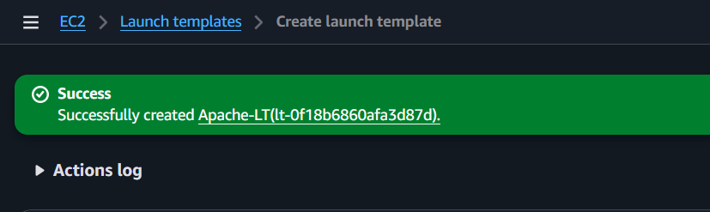

Part B: Create an Auto Scaling Group
- Go to EC2 Console → Auto Scaling Groups.
- Click Create Auto Scaling group.
- Configure:
  - Name: Apache-ASG
  - Launch template: Apache-LT
- Click Next.
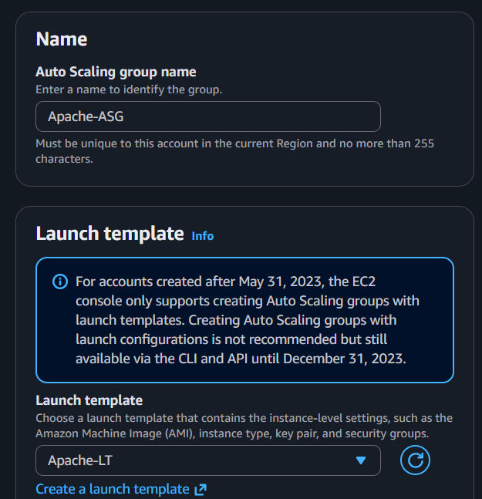

Part C: Configure Network
- Select:
  - VPC: Demo-VPC
- Choose the subnets where instances should launch:
  - Public-Subnet
  - Public-Subnet-2
- Click Next.
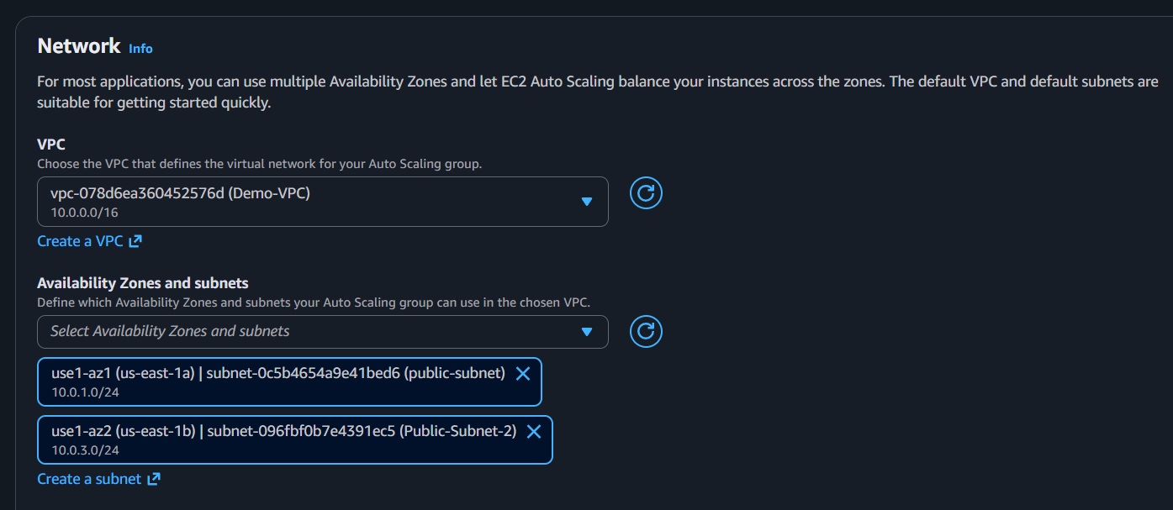

Part D: Attach to Load Balancer
- Select:
Attach to an existing load balancer
- Choose:
Choose from your load balancer target groups
- Select:
Apache-TG
- Click Next.
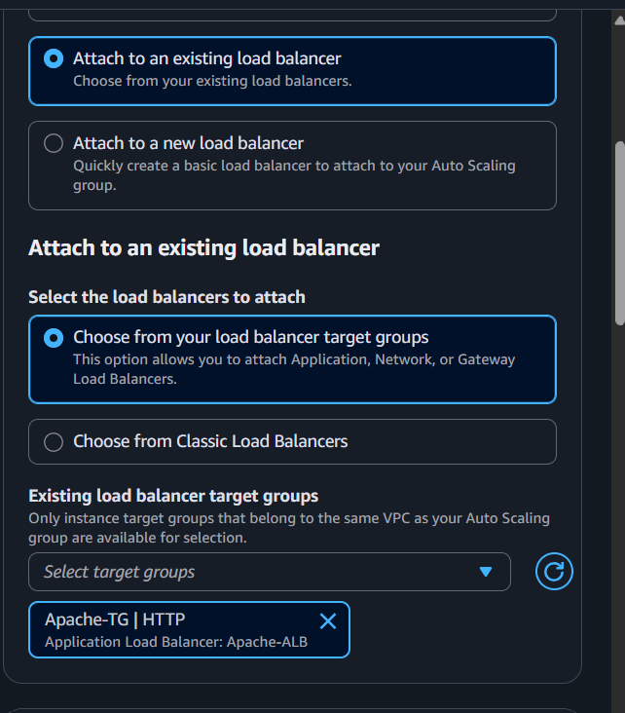

Part E: Configure Group Size
Set:
- Desired Capacity: 2
- Minimum Capacity: 2
- Maximum Capacity: 4
Click Next.
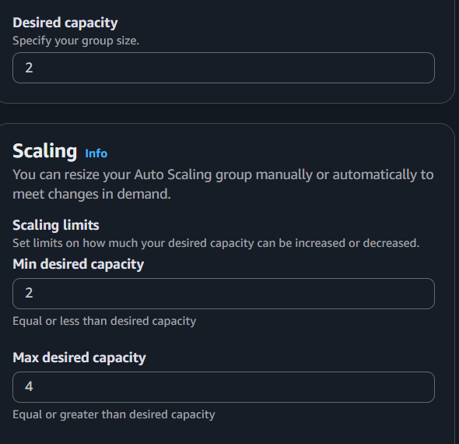

Part F: Configure Scaling Policy
- Select:
Target tracking scaling policy
- Configure:
  - Policy name: CPU-70
  - Metric type: Average CPU Utilization
  - Target value: 70
- Leave the remaining settings as default.
- Click Next.
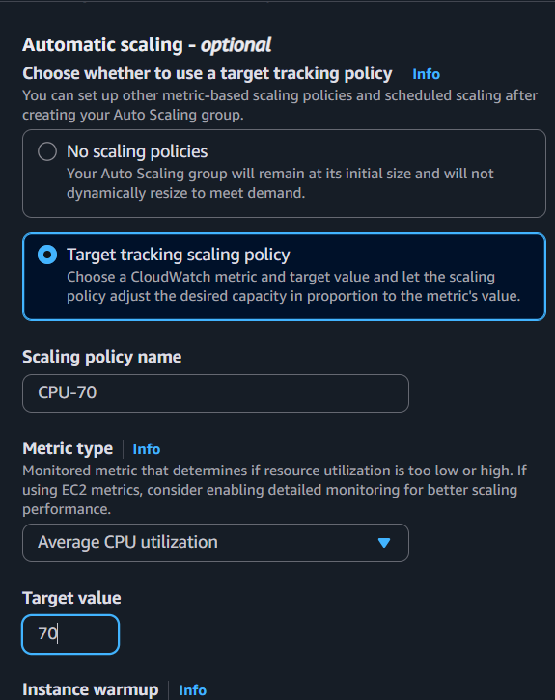
- Review the configuration.
- Click Create Auto Scaling group.
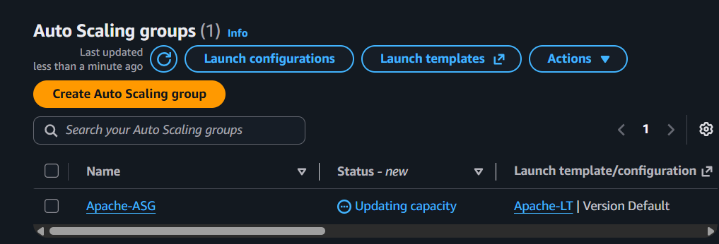

Part G: Test Auto Scaling
- Connect to one of the EC2 instances.
- Install the stress utility:
sudo dnf install stress -y
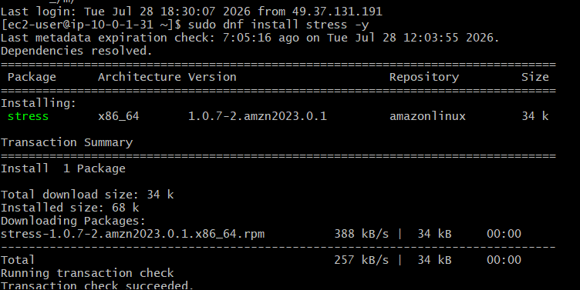
- Generate CPU load:
stress --cpu 2 --timeout 300
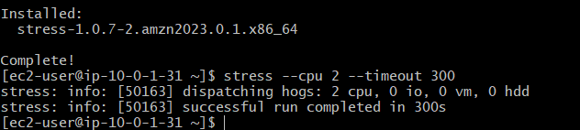
- Go to:
  - CloudWatch → Metrics and verify CPU utilization exceeds 70%.
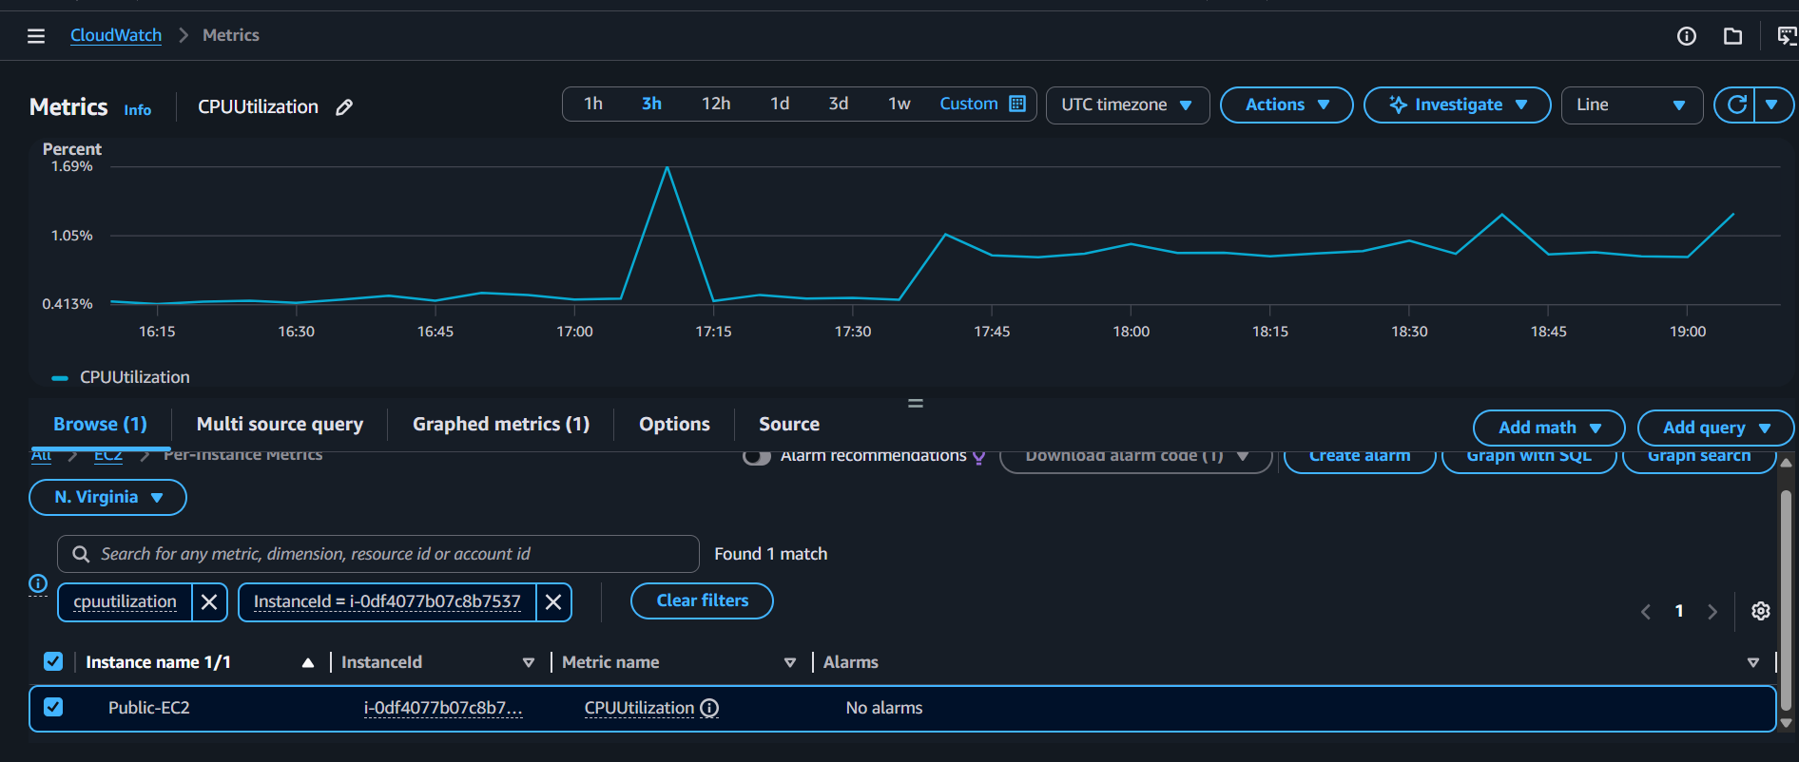
  - EC2 → Auto Scaling Groups → Activity and observe that a new EC2 instance is launched.
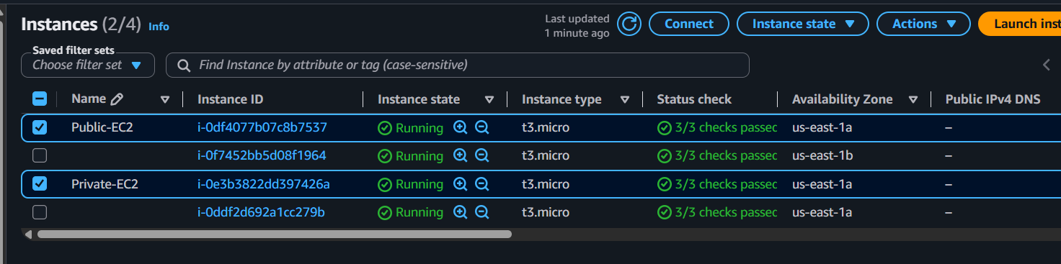

Expected Outcome
- A Launch Template named Apache-LT is created.
- An Auto Scaling Group named Apache-ASG is created.
- The Auto Scaling Group is attached to the Apache-TG target group.
- When average CPU utilization exceeds 70%, the Auto Scaling Group automatically launches a new EC2 instance.
- The new instance is automatically registered with the Application Load Balancer and begins serving traffic once it passes health checks.

